

***SQL-ites***

***Client -Tucson Foods***

**Team**

**Ajay Jaswani**

**Aliptha Nagaraju**

**Mridul Wadhwa**

**Shivani Dandir**

**Karan Sachdeva**

**Johan Jacob**

**Index**

**Client Background** **3**

**Users** **4**

**Database Need** **4**

**Problem Statement** **5**

**ER Diagram** **6**

ER Part 1 8

**ER Part 2** **9**

**Data Dictionary** **10**

**Normalized Tables** **14**

**Queries** **16**

Query 1 (View Rider Ranks) 16

Query 2 (View Order Stats) 17

Query 3 (Customers Total Orders Placed From A Restaurant) 19

Query 4(View Rider Stats) 20

Query 5(View Restaurant Category) 21

Query 6 (Department Statistics) 22

Query 7(Restaurants Last Order Date) 23

Query 8 (View Item Types) 24

Query 9 (View Customer Stats) 25

Query 10(View Most Ordered Items) 26

Query 11(View Quarter wise Revenue) 27

Query 12(View Popular Restaurants) 29

**Trigger and Procedures** **30**

Trigger 1 30

Trigger 2 31

Procedure 1 32

**User Interface** **33**

Welcome Page 33

Register Page 33

User Profile Page 34

Restaurant Page 35

Menu Page 35

Special Queries Page 36

Customer Stats Page 37

Popular Restaurants Page 38

Item Types Page 38

Customers Total Order from restaurant page 39

Restaurant last Order Page 39

Rider Stats Page 40

Restaurant Category 40

Order Stats Page 41

Most Ordered Items Page 42

Rider Ranking Page 42

Quarter Wise Revenue Page 43

Department Statistics 44

**Implementation Plan** **44**

**Appendix** **45**

Lessons Learned 45

**Chapter 3 SQL Table Creation Script** **45**

## 

## Client Background

Tucson Foods is a small-scale food delivery company that currently targets the elderly in Tucson, Arizona, to provide a prompt and efficient service from their favorite restaurants. The current business model works on an in-store offline model where you either have the option to set up a subscription to your favorite restaurants and have the food delivered to your doorstep. Tucson Foods currently only targets the elderly to help give back to the community and provide a service to those who don't have access to a plethora of options. However, with the advent of Covid, every business moved to an online model to keep the business running and bring in revenue through online platforms. Tucson Foods sees this as the perfect opportunity to establish an online presence and broaden their clientele to include younger individuals who have easy access to the internet and are well informed about various online platforms. This would serve as the perfect opportunity to expand the business and reach a larger population while also focusing on the in-store subscription model as they value their roots. To facilitate this and set up an online food delivery application, Tucson foods contacted a group of young professionals to set up an end-to-end system, which involves an in-depth analysis of the existing architecture and design of a data model based on the findings. The data model has to be translated into tables, and a database has to be set up from scratch to store all the data. They also require a functional website that helps customers view restaurants and menus and place an order for their favorite items from desired restaurants. They also need a functionality wherein a customer can provide feedback to the restaurant based on their personal experience so that Tucson Foods can ensure that customers are satisfied and are getting the best service possible.

## Users

The users that will most frequently log in to the system would be the end customers who should view the restaurants and their corresponding menus and place an order based on their preferences. We need to provide functionality for existing users to log in and for new users to register with us by signing up through the registration page. A new user can come in either with or without a referral. By providing a few basic details, the new user can be registered with us and access all the website’s features. A returning customer would directly be navigated to the restaurant pages to pick their desired dishes and place an order.

## Database Need

Since Tucson Foods currently carries out business in an offline in-store model, they do not have a database in place and maintain physical records essential software to store their customer data. Having an Oracle database in place would be incredibly beneficial for Tucson Foods going forward as they plan on expanding their clientele and establishing an online presence. The database could directly be linked with the front end, which will make it easy to keep track of the transactions, and the changes will reflect on the database. Customer data, restaurant data, menu data, order data, etc., would automatically be updated or inserted into the database based on activities performed on the website. It can help reduce the time spent keeping physical log entries and adds security as you would need credentials to log in to view the data. It has the added benefit of quickly retrieving and accessing your data when need is and better understanding the relationship between them. Different queries can be run on the database to display statistics which would be instrumental in measuring how the business is performing and areas of improvement as the volume of data increases. Also, easy storage and access method become even more necessary to keep the system efficient and adequately utilized.

## Problem Statement

We are building a food delivery-based application. For a customer to use an application, they must register to the platform. At the time of Registration – username, password are stored for the customer, and they answer the security question of their choice. Further, after registration, the customer is prompted to enter details - first name, last name, an email, a mobile number, and customer address (state, zip, city, and street). They have a password and a unique customer id. A customer can register in the application only once, i.e., every customer has a unique username.

During registration, a customer can enter a referral code. Upon successful sign up the customer also gets their unique referral code, which they can use to refer new customers. For every referral, we store a referralID that indicates a user’s transaction signed up. We also keep Referral Discount, Referral Date. A customer can only use one referral code for registration, but a registered customer can refer to many new potential customers.

The application has partnered with restaurants to deliver food. It stores the details of the restaurants like – a unique restaurant id, restaurant name, restaurant address, opening time, closing time, partners since, owner name, owner phone number.

Each restaurant has one or many points of contact, and the application stores them for the customer’s reference. The restaurant point of contact details includes- a Contact Id, first name, last name, phone number, email, point of contact since, and point of contact’s designation at the restaurant. A point of contact is only associated with one restaurant.

Each restaurant has its menu with some items listed for delivery. We store item details like – itemId, item name, item price, item description. Each restaurant has more than one Menu but one Menu belongs to one restaurant only.

The customer uses the app to order food from the restaurants, for each order made on the app, we store details like – a unique order id, order date, order time, delivery address. A customer can place multiple orders and the order is associated with one customer.

A customer can choose the payment mode to pay for their order. For every payment mode, we store details like PamentID, total price of the order, discount, delivery fee, and the final amount calculated based on them.In the case of the card we store – card number, name, CVV, expiry date, card type. A payment is done by one card only but the same card can have multiple payments.

A customer can use various offers to get a discount on order, an offer must include – Offer Id (PK), offer name, offer code, condition, offer start date, offer end date. We can apply a maximum of only one offer on each order.

Once the payment is confirmed, an order is placed and delivery services are invoked.

For one payment only one delivery service is prompted. For a delivery service we store – deliveryID, delivery address, pickup location, time to delivery. A delivery service is provided by a single delivery agent. A delivery agent can do multiple deliveries. A delivery agent has activeStatus, ratings, currentLocation and No of trips. A delivery agent owns a single vehicle. For every vehicle that a rider rides, we store details like – VIN, vehicle number, insurance number, vehicle color, year of manufacture, type.

We also take feedback from the customer for the restaurant which has a unique feedback id, rating, date and time the feedback was given on. A customer can give many feedbacks and feedback is always associated with a customer.

We also want to store data for employees, including employee ID, hire date, SSN (unique and required for all employees), name (first, middle initial, and last name), blood group. Employees are divided into various roles, e.g., managers, support agents, delivery agents, etc. For managers we need to know the years of experience, number of employees under him/her, practice he/she belongs to. For delivery agents we need to know the number of trips, their current location, ratings, and active status. We also have a support agent to handle queries, we store query type, details of query, status of query (resolved, open).

Each employee is associated with a department and department stores departmentID, department name, Cost Center. A department can have multiple employees.

The company also hires external contractors as human capital for special roles. For every contractor hired we store, contractor id, first name,last name, special skills, company name, contractor’s supervisor ID, billing per hour, contract start date, contract end date. A contractor reports to only one manager but a manager can manage multiple contractors.

We store payroll information of the employee which includes employee id, payment begin date, payment end date, pay rate, taxes. Employees can get paid multiple times and each payroll is associated with only one employee.

We use technology services such as cloud databases, security tools, payment gateways, for which we need services from technology vendors. For every vendor we have a vendorId, Name, Contract Start Date, Contract End Date, Contract Amount, Technology Used. A vendor is managed by only one manager and a manager can manage many vendors.

## ER Diagram

The below entity relationship diagram covers the various entities and relationships in our model and their cardinality for the relationship.

This diagram captures the user journey as he or she navigates through the process of registering and ultimately placing an order as well as other components which are used to store supplementary information about the system.

Our conceptual model has the following counts for strong and weak entities.

Strong entities : 17

Weak entities and Sub-Classes : 6

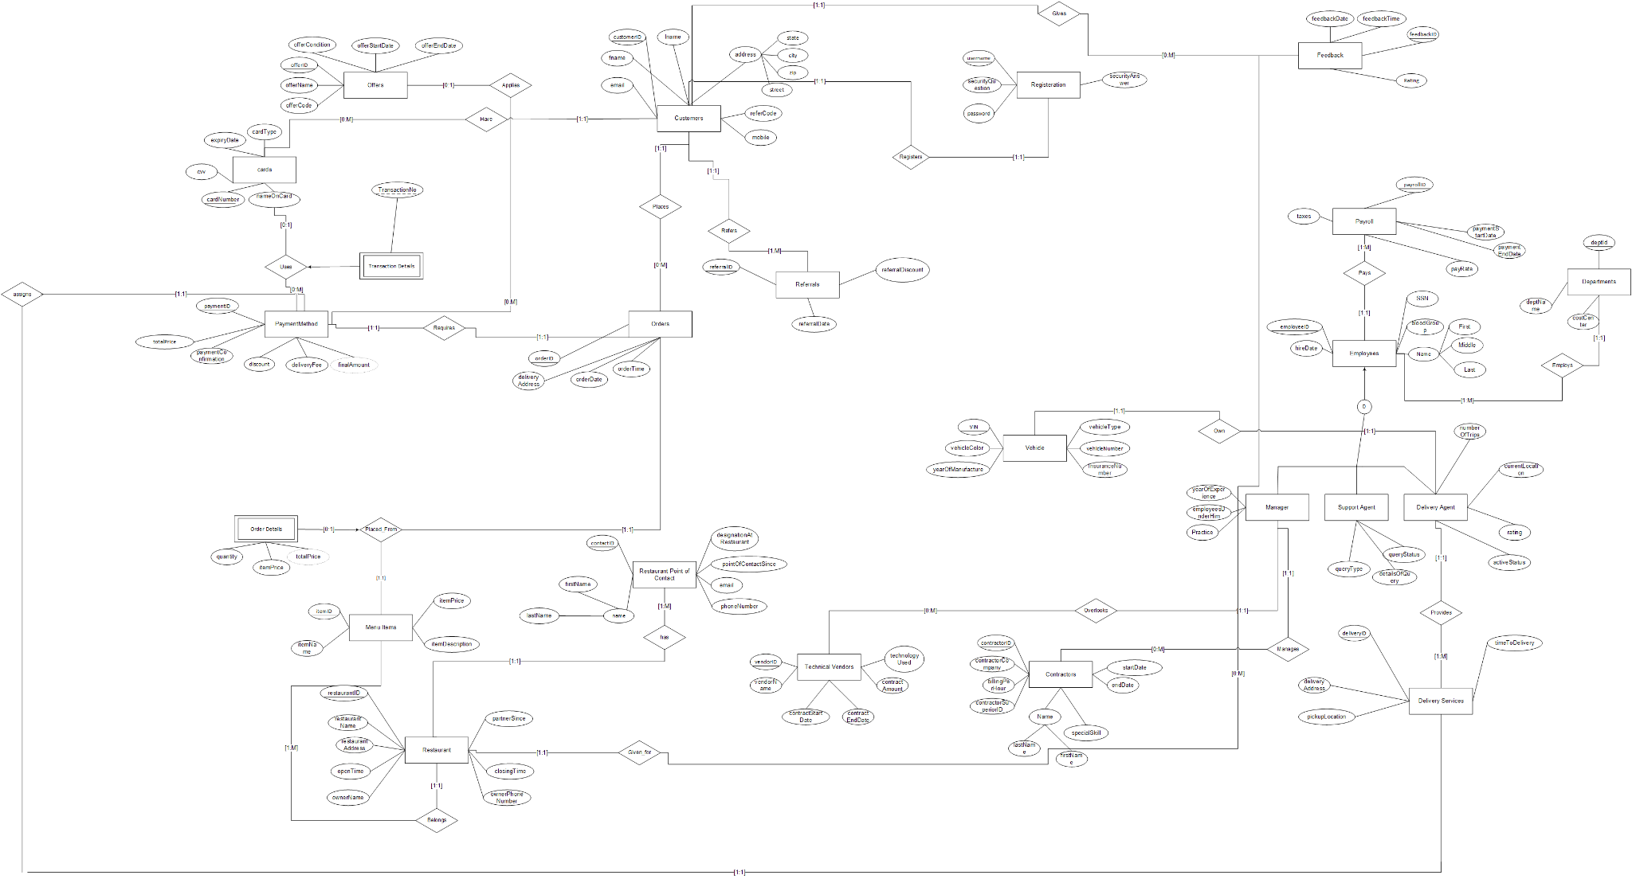

The above ER has been split into two portions based on our requirements and areas of focus

### **ER Part 1**

This part of the ER deals with all the primary information that is incorporated into the user journey and the tables that will either be queried from or inserted into while carrying out the process. It starts with the Registration table which stores the registration data of a customer, followed by the Customer table which stores the customer information. Furthermore, we use the restaurant table and the Menu Items table to display the list of restaurants and their corresponding Menu to the user. After selecting the desired items, an order can be placed followed by a payment to confirm the order. This part also contains certain additional tables that don't necessarily define the user journey but contribute to it in some way, for example the offers table which is used to store the offer details which could be referenced during a payment for an order.

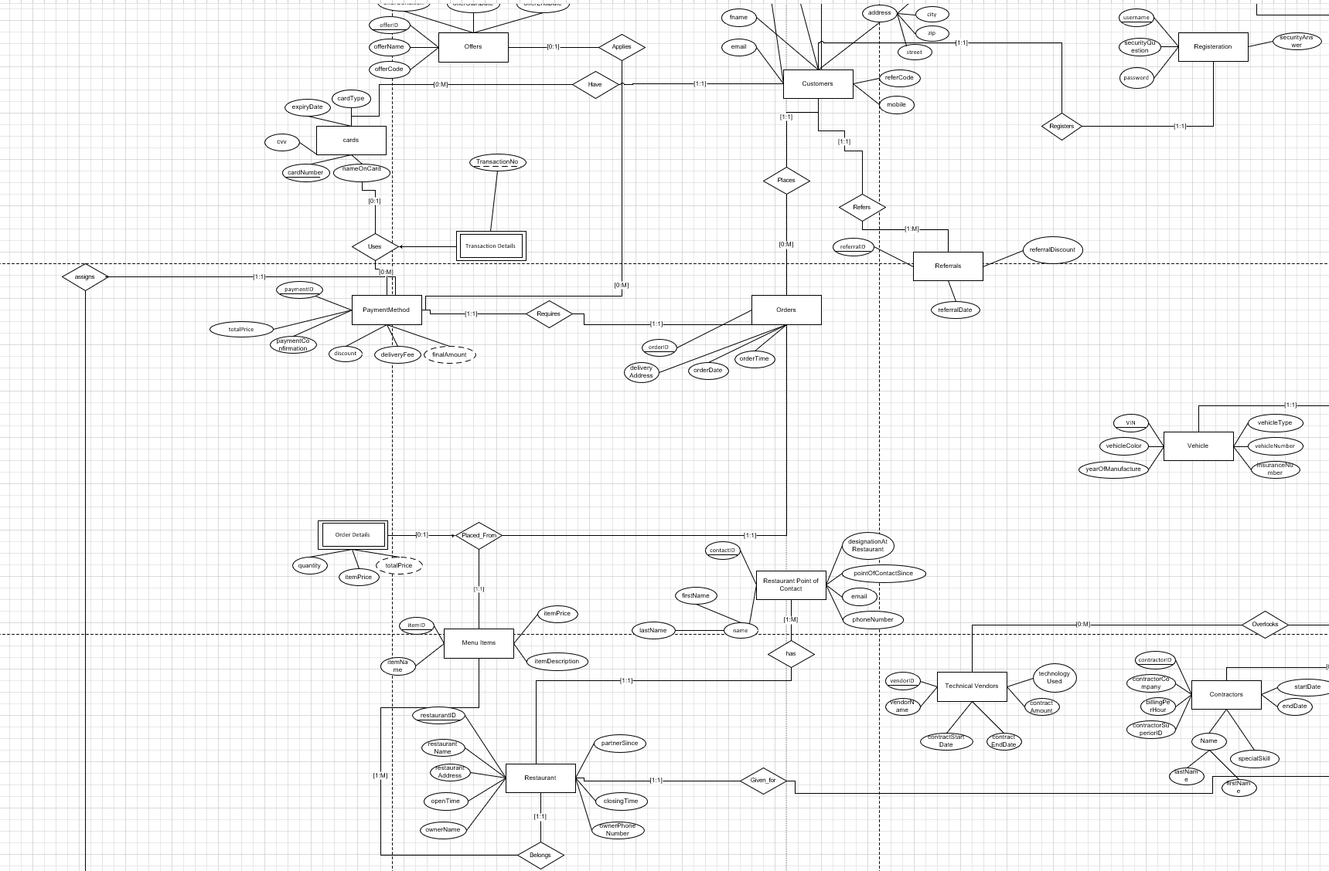

### **ER Part 2**

This part of the ER covers the information that is definitely crucial to the organization as a whole but not instrumental in defining the user journey. The half of the ER mostly comprises the Employee data along with the different types of Employees who work in our organization, their payroll and the department they belong to. It also displays the tables which store the contractor and technical vendor information for our system and the managers within the organization and are tasked with managing and overlooking their activities and functioning. We also store information about the delivery service and the delivery agent who is assigned to an order at a time and is tasked with delivering the order to the specified delivery address. The information about the vehicle owned by the delivery agent is stored in the vehicle table.

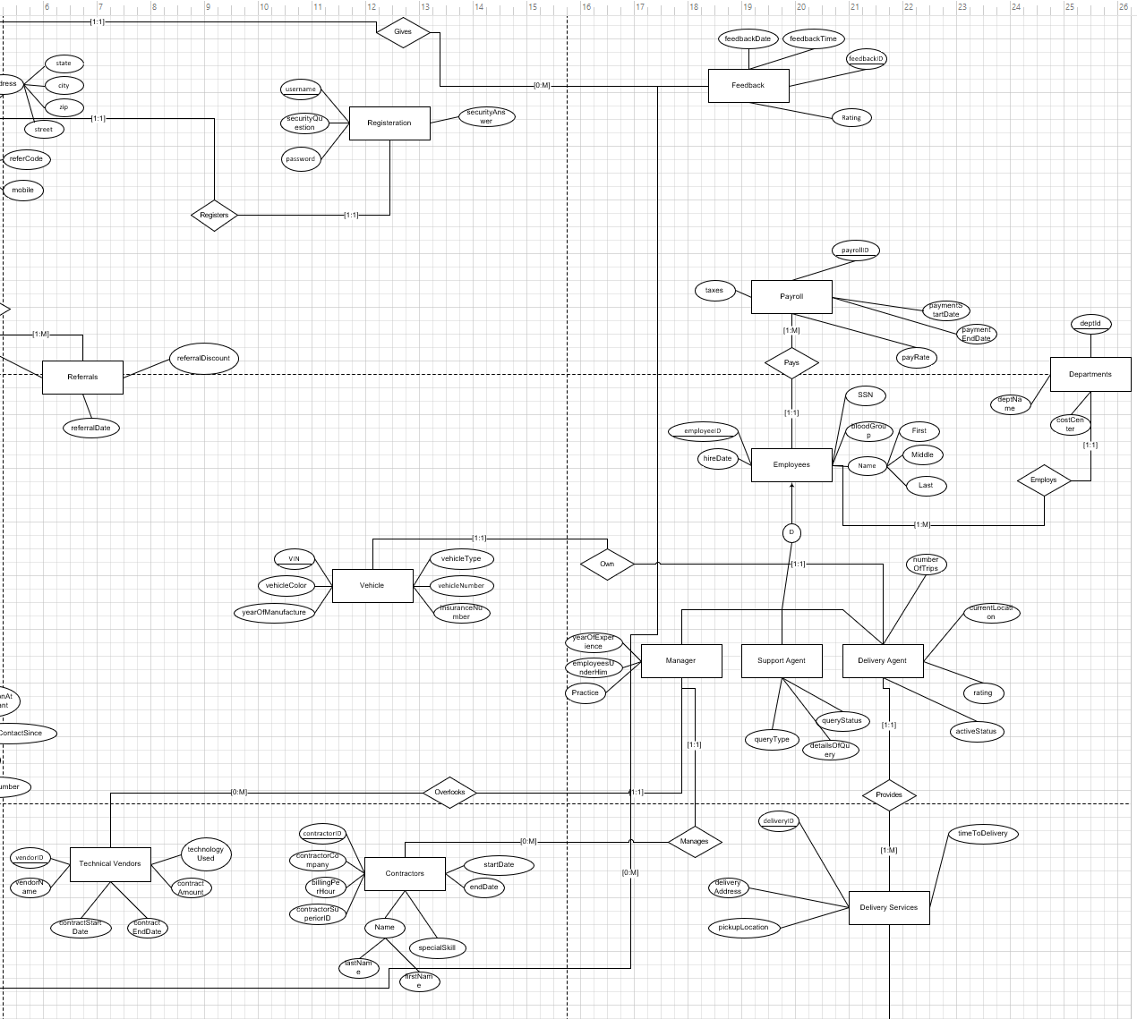

## Data Dictionary

The data dictionary shows the list of all the entities including the strong and weak entities along with their relationships to each other. The data dictionary gives a short description of what every field in a table is being used for as well as any constraints or checks that might be applied based on the business use case and requirements.

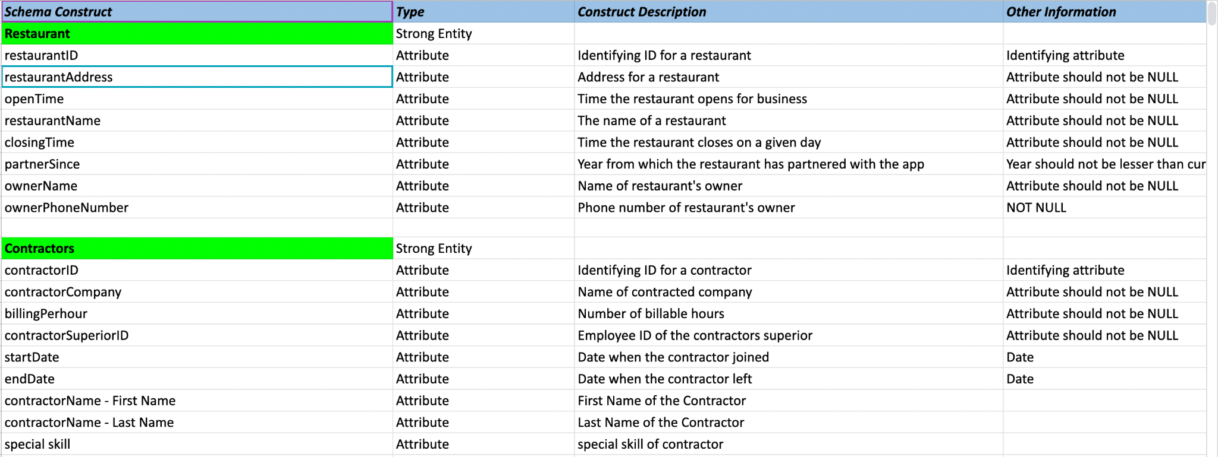

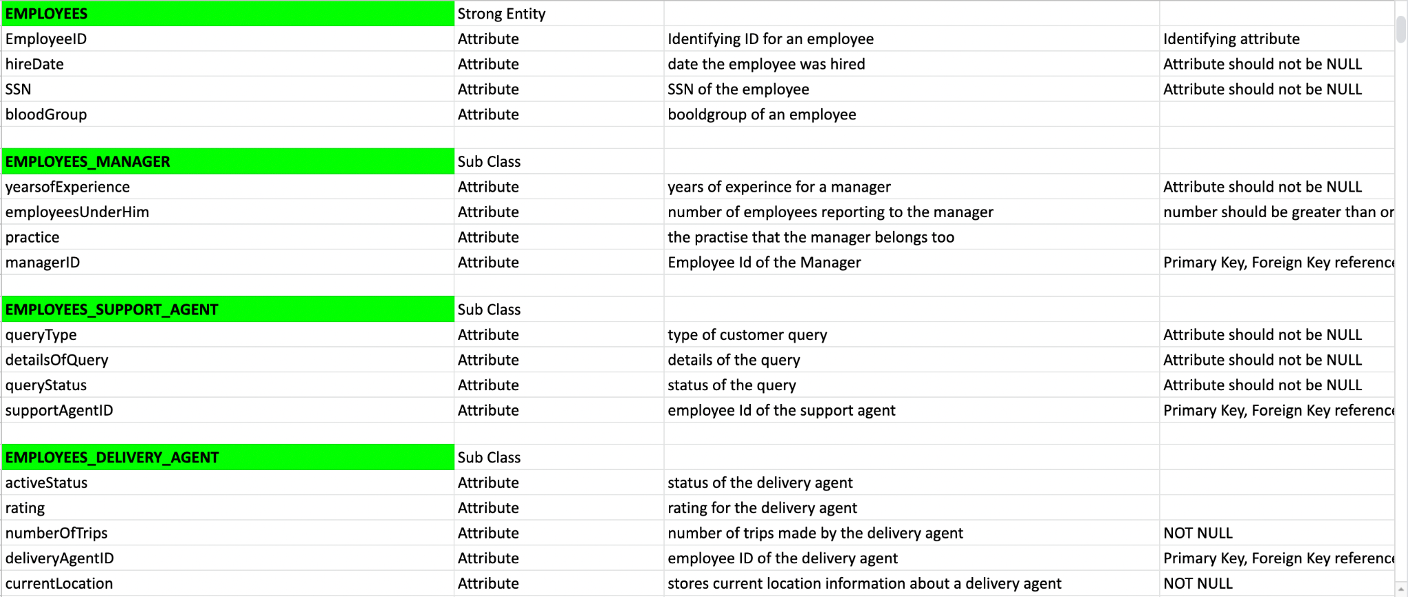

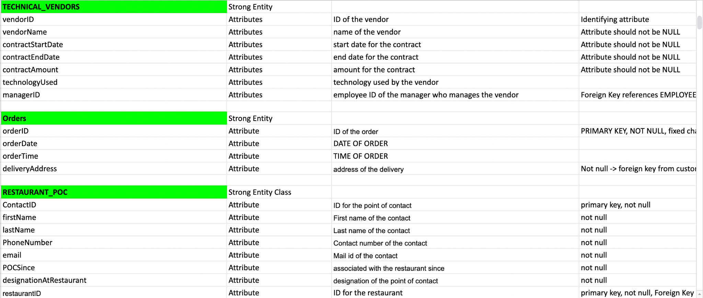

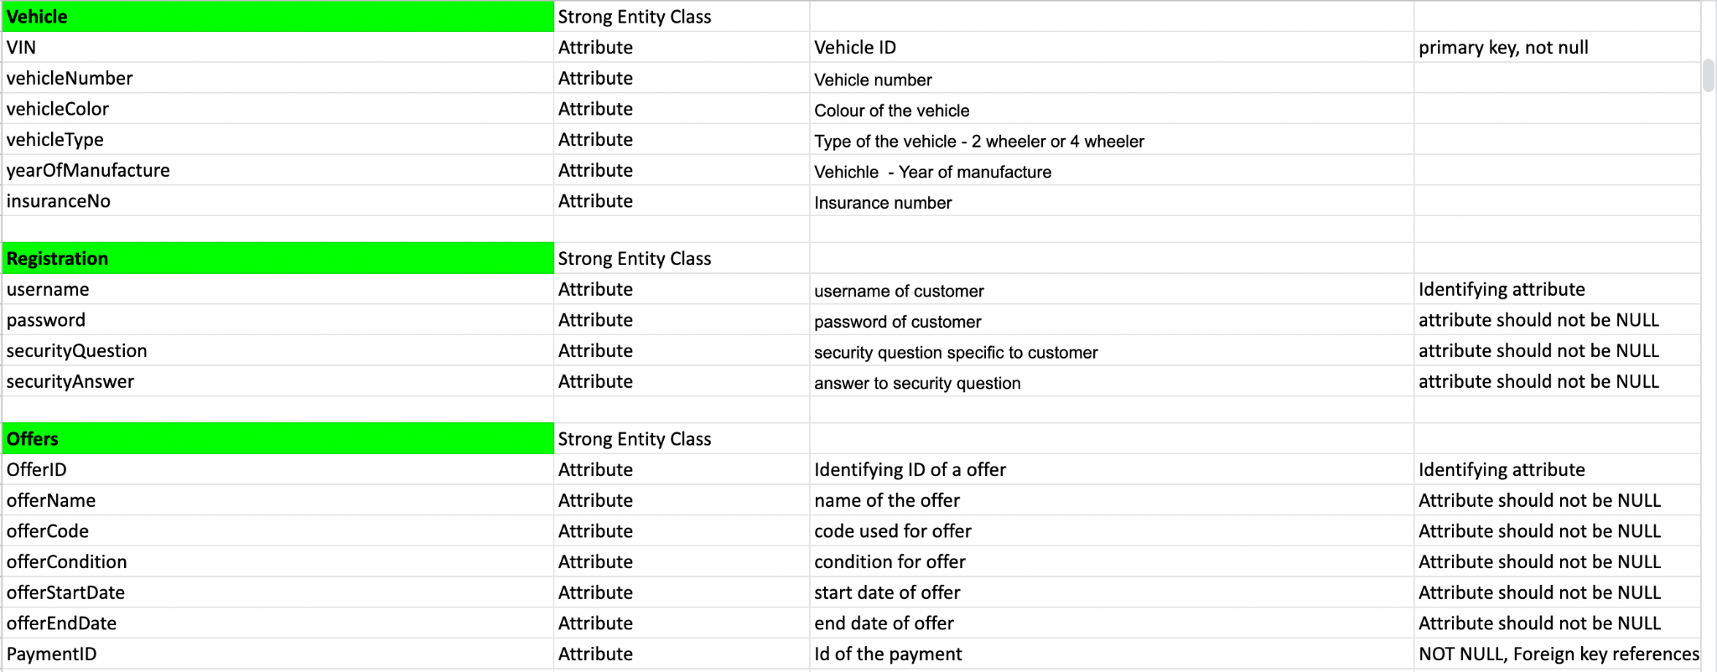

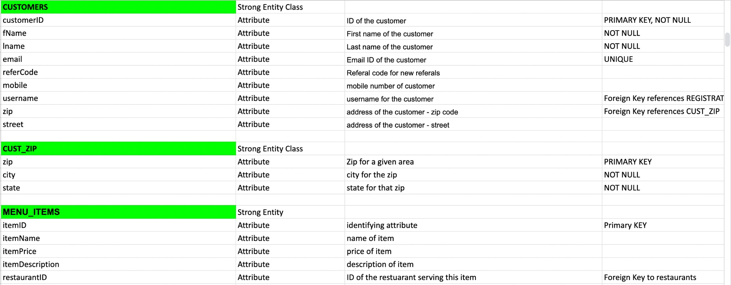

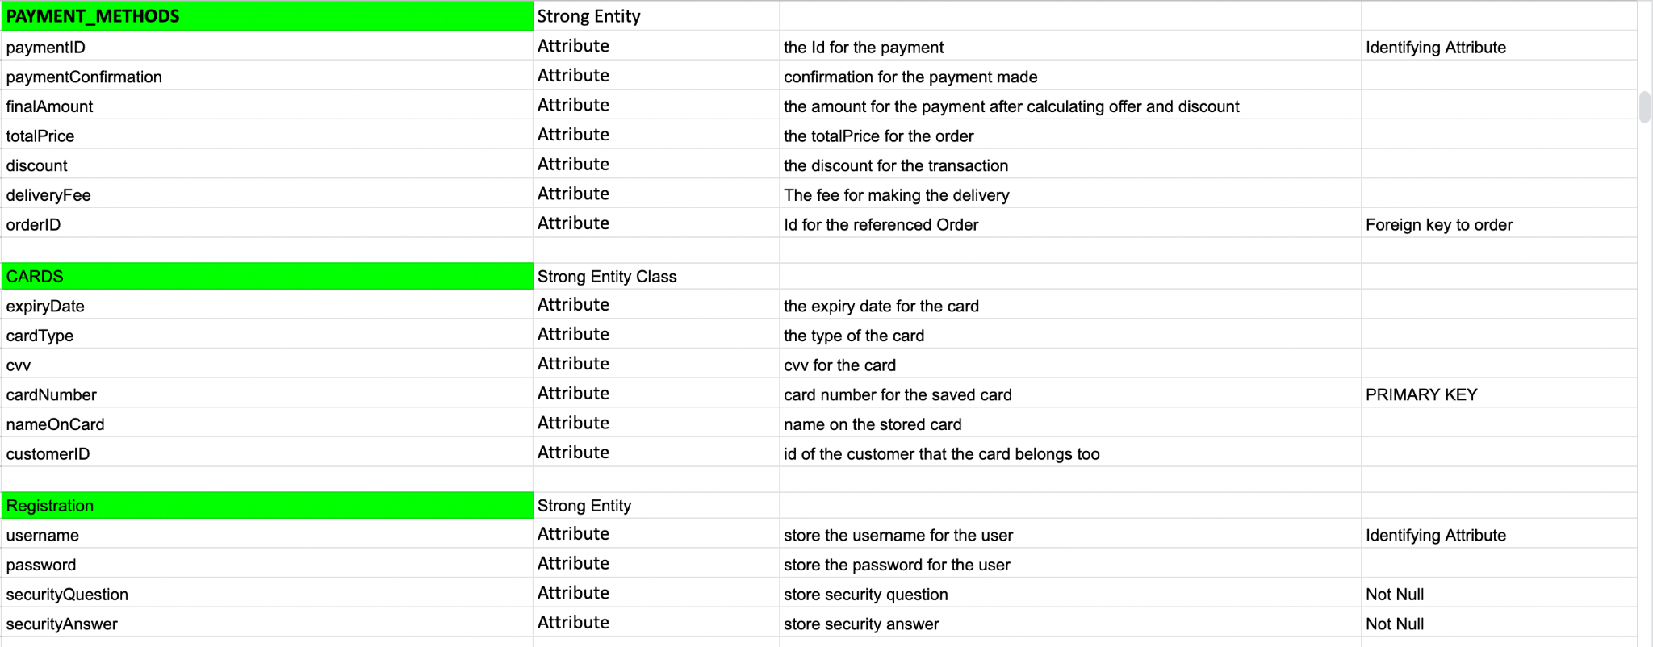

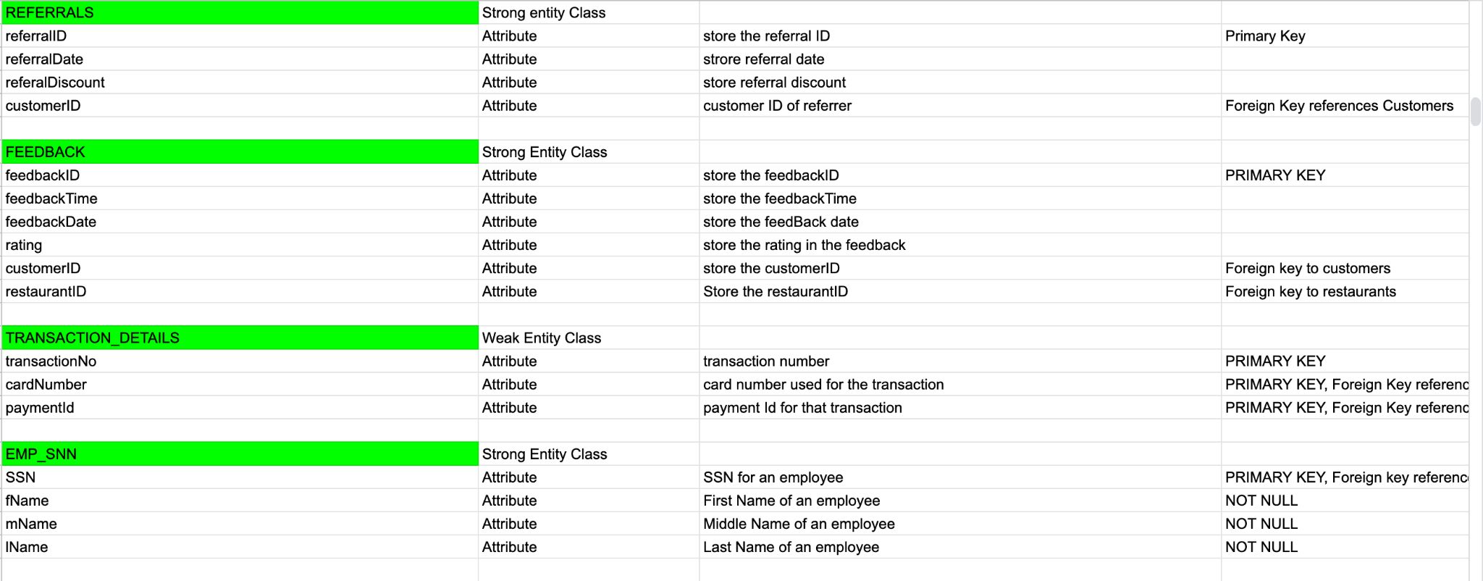

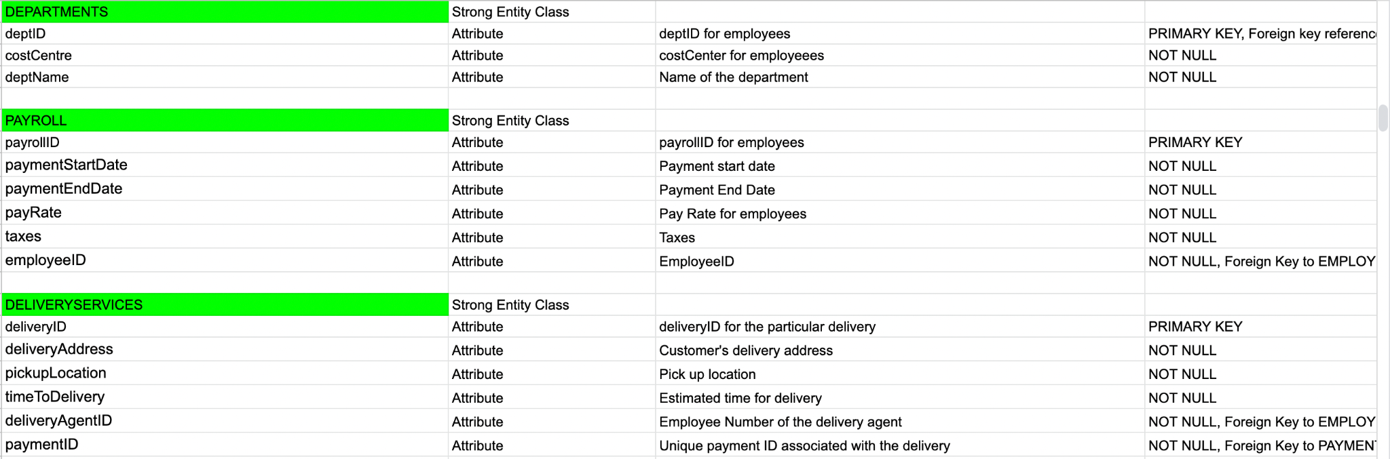

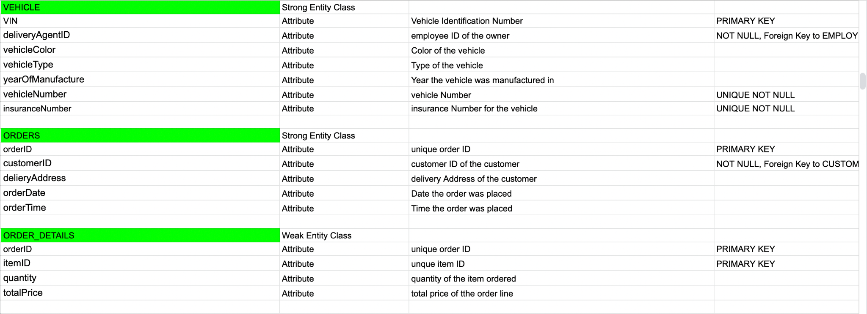

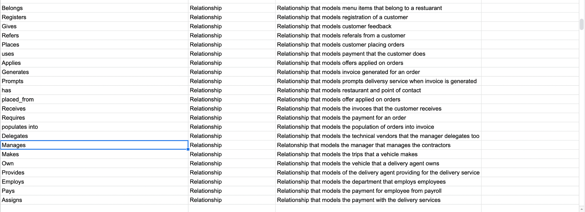

## 

## Normalized Tables

The table structure was created from the ER diagram using ER to relational and further normalized to 4NF to ensure atomicity and avoid transitive dependencies, partial dependencies and multivalued attributes.

REGISTRATION (username, securityQuestion, password, securityAnswer)

CUSTOMERS (customerID, fname, lname, email, mobile, street, zip, referCode, username)

Foreign Key (username) references Registration (username)

CUST_ZIP (zip,city, state)

Foreign Key (zip) references CUSTOMERS (zip)

REFERRALS (referralID, referalDate,referralDiscount, customerID )

Foreign key (customerID) references Customers(customerID)

FEEDBACK (feedbackID, feedbackTime, feedbackDate, rating, customerID)

Foreign key (customerID) references Customers(customerID)

ORDERS (orderID, customerID, deliveryAddress, orderDate, orderTime)

Foreign Key (customerID) references CUSTOMERS (customerID)

ORDER_DETAILS (itemID, orderID, quantity, totalPrice(derived))

FOREIGN KEY (itemID) references MENU (itemID)

FOREIGN KEY (orderID) references ORDERS (orderID)

MENU_ITEMS (itemID, itemName, itemPrice, itemDescription, restaurantID)

FOREIGN KEY (restaurantID) references RESTAURANT (restaurantID)

PAYMENT_METHODS (paymentID, paymentConfirmation, finalAmount, totalPrice, discount, deliveryFee, orderID)

Foreign Key (orderID) references ORDERS (orderID)

CARDS (cardNumber, cardType, expiryDate, cvv, nameOnCard,customerID)

Foreign Key (customerID) references CUSTOMERS (customerID)

TRANSACTION_DETAILS (transactionNo, cardNumber, paymentID)

FOREIGN KEY cardNumber REFERENCES CARDS cardNumber  
FOREIGN KEY paymentID REFERENCES PAYMENT_METHODS

OFFERS (offerID, offerName, offerCode, offerCondition, offerStartDate, offerEndDate, paymentID)

FOREIGN KEY (paymentID) references PAYMENT_METHODS (paymentID)

RESTAURANT (restaurantID, restaurantName, restaurantAddress, openTIme, closingTime, partnerSince, ownerName, ownerPhoneNumber)

RESTAURANT_POC (contactID, restaurantID, firstName, lastName, designationAtRestaurant, POCSince, eMail, phoneNumber)

FOREIGN KEY restaurantID references RESTAURANT (restaurantID)

EMPLOYEES (employeeID, hireDate, SSN, bloodGroup,deptId)

FOREIGN KEY (deptID) references DEPARTMENTS (deptID)

EMP_SSN(SSN, fName, mName lName)

FOREIGN KEY (SSN) references EMPLOYEES (SSN)

EMPLOYEES_MANAGER (mangerID, yearOfExperience, employeesUnderHim, practice)

FOREIGN KEY (mangerID) references EMPLOYEES(employeeID) EMPLOYEES_SUPPORT_AGENT(supportAgentID, queryStatus, detailsOfQuery, queryType)

FOREIGN KEY (supportAgentID) references EMPLOYEES(employeeID)

EMPLOYEES_DELIVERY_AGENT(deliveryAgentID,numberOfTrips currentLocation, rating, activeStatus)

FOREIGN KEY (deliveryAgentID) references EMPLOYEES(employeeID)

TECHNICAL_VENDORS(vendorID, vendorName, contractStartDate, contractEndDate, contractAmount, technologyUsed, mangerID )

FOREIGN KEY (mangerID) references EMPLOYEES_MANAGER(mangerID)

DEPARTMENTS (deptID, costCentre, deptName )

PAYROLL (payrollID, paymentStartDate, paymentEndDate, payRate, taxes, employeeID)

FOREIGN KEY (employeeID) references EMPLOYEES (employeeID)

DELIVERYSERVICES (deliveryID, deliveryAddress, pickupLocation, timeToDelivery, deliveryAgentID, paymentID)

FOREIGN KEY (deliveryAgentID) references DELIVERY_AGENT (employeeID)

FOREIGN KEY (paymentID) references PAYMENT_METHODS(paymentID)

CONTRACTORS (contractorID, contractorCompany, billingPerHour, contractorSupervisorName, fName, lName , specialSkills, startDate, endDate, managerID )

FOREIGN KEY (managerID) references MANAGERS (managerID)

VEHICLE (VIN, deliveryAgentID, vehicleColor, vehicleType, yearOfManufacture)

FOREIGN KEY (deliverAgentID) references DELIVERY_AGENT (deliveryAgentID)

## Queries

Stated below are the 12 complex queries that are being used to derive different kinds of statistics which gives a better view of the data and can be used to make informed business decisions to help grow the company further and achieve highest customer satisfaction.

### Query 1 (View Rider Ranks)

Rank the rider based on the number of orders he/she has delivered and their average star rating.

CREATE OR REPLACE VIEW v_rider_rank AS

WITH rider_rank AS (

SELECT

ds.deliveryagentid AS "Rider",

COUNT(pm.paymentid) AS "TotalNumber_of_rides",

AVG(eda.rating) AS "Average_rating"

FROM

orders o

JOIN payment_methods pm ON o.orderid = pm.orderid

JOIN deliveryservices ds ON pm.paymentid = ds.paymentid

JOIN employees_delivery_agent eda ON ds.deliveryagentid = eda.deliveryagentid

GROUP BY

ds.deliveryagentid

)

SELECT

"Rider",

"TotalNumber_of_rides",

"Average_rating",

RANK()

OVER(

ORDER BY

"TotalNumber_of_rides", "Average_rating" DESC

) "Rider_rank"

FROM

Rider_rank;

Output:

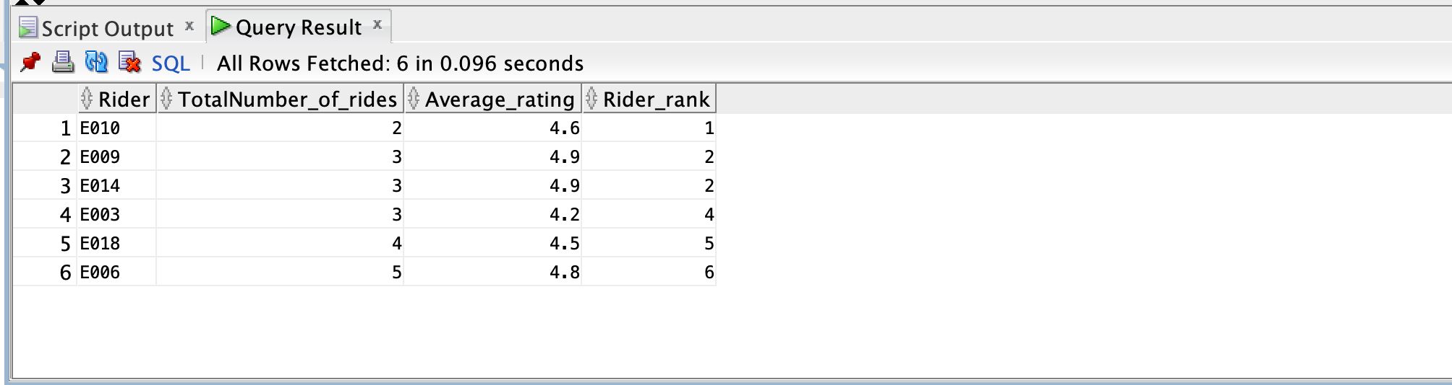

### Query 2 (View Order Stats)

Get order records for a particular month, choose November for this query. Calculating Orders placed today, a week ago, and previous day

CREATE OR REPLACE VIEW v_order_stats AS

WITH dates AS (

SELECT

day_of_month AS "OrderDate"

FROM

(

SELECT( level - 1 ) + trunc(TO_DATE('11/01/2021', 'MM/DD/YYYY'), 'MM') day_of_month

FROM

dual

CONNECT BY

level <= 31

)

WHERE

day_of_month < add_months(trunc(TO_DATE('11/01/2021', 'MM/DD/YYYY'), 'MM'), 1)

), eq AS (

SELECT

to_char("OrderDate") AS "OrderDate",

COUNT(o.orderid) AS "OrdersToday",

(

SELECT

COUNT(o.orderid)

FROM

orders o

WHERE

( "OrderDate" - 7 ) = o.orderdate

) AS "WeekAgo",

coalesce(LAG(COUNT(o.orderid))

OVER(

ORDER BY

"OrderDate"

),(

SELECT

COUNT(o.orderid)

FROM

orders o

WHERE

orderdate = '31-OCt-2021'

)) AS "PreviousDay"

FROM

dates

LEFT JOIN orders o ON dates."OrderDate" = o.orderdate

GROUP BY

"OrderDate"

ORDER BY

"OrderDate"

)

SELECT

"OrderDate",

"OrdersToday",

"WeekAgo",

"PreviousDay",

"OrdersToday" - "WeekAgo" AS "WeeklyChange",

"OrdersToday" - "PreviousDay" AS "DailyChange"

FROM

eq

UNION

SELECT

'Total',

SUM("OrdersToday"),

0,

0,

0,

0

FROM

Eq;

Output:

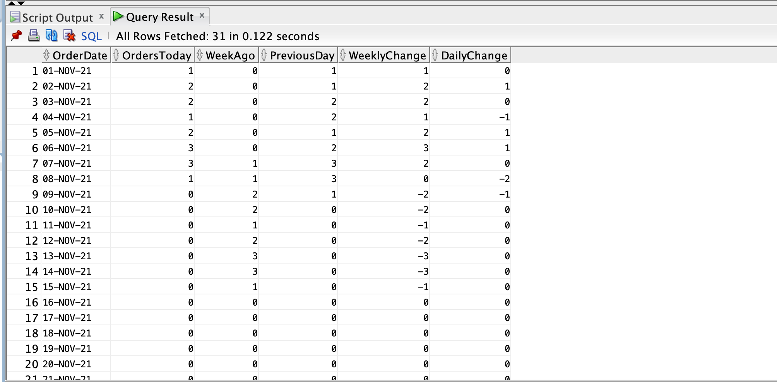

### Query 3 (Customers Total Orders Placed From A Restaurant)

For a customer, display the count of the orders that customer has ordered from different restaurants.

CREATE OR REPLACE VIEW v_customer_restaurant_order AS

SELECT

c.customerid,

COUNT(o.orderid) AS "Totalnumber_of_orders",

r.restaurantid

FROM

customers c

JOIN orders o ON o.customerid = c.customerid

JOIN order_details od ON o.orderid = od.orderid

JOIN menu_items m ON m.itemid = od.itemid

JOIN restaurant r ON m.restaurantid = r.restaurantid

GROUP BY

c.customerid,

r.restaurantid

WITH CHECK OPTION;

Output:

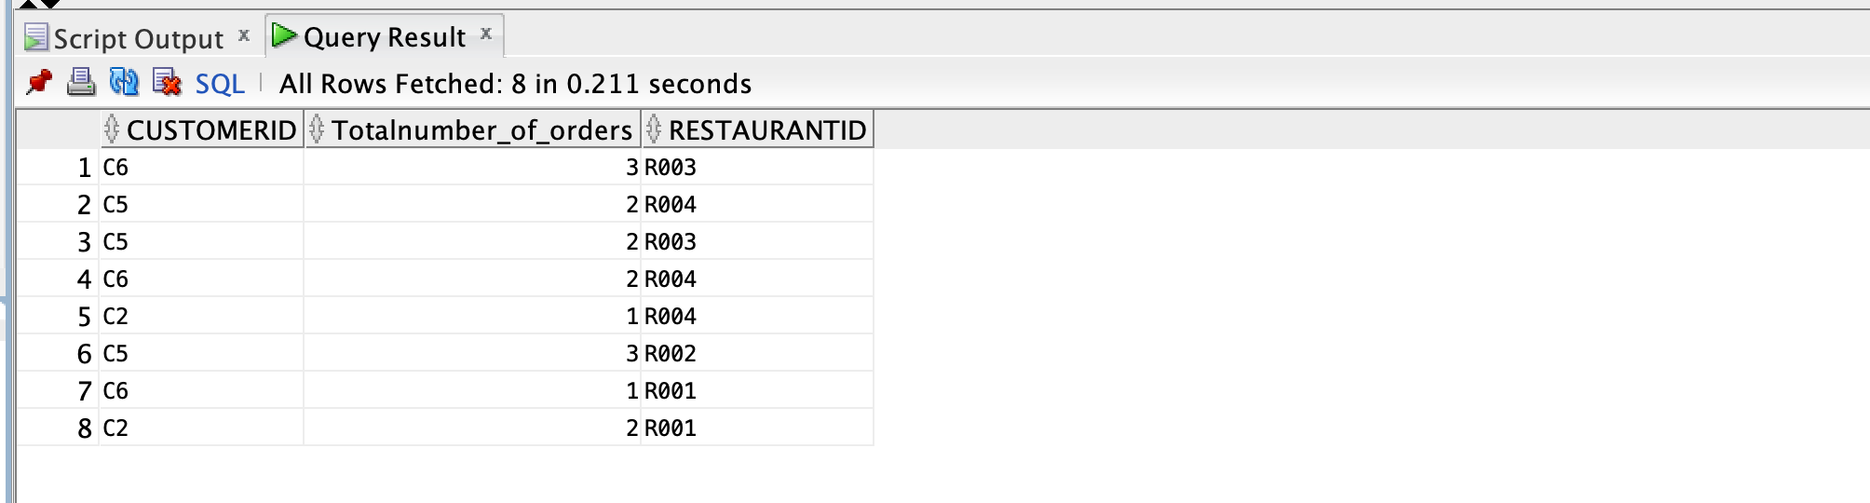

### Query 4(View Rider Stats)

Display rider Id, total number of orders he delivered, total revenue of the orders he has delivered.

CREATE OR REPLACE VIEW v_riders_stats AS

SELECT

eda.deliveryagentid,

SUM(pm.finalamount) AS "Total_revenue",

COUNT(o.orderid) AS "Numberoforders"

FROM

payment_methods pm

JOIN orders o ON o.orderid = pm.orderid

JOIN deliveryservices ds ON ds.paymentid = pm.paymentid

JOIN employees_delivery_agent eda ON eda.deliveryagentid = ds.deliveryagentid

GROUP BY

eda.deliveryagentid

WITH CHECK OPTION;

*Output:*

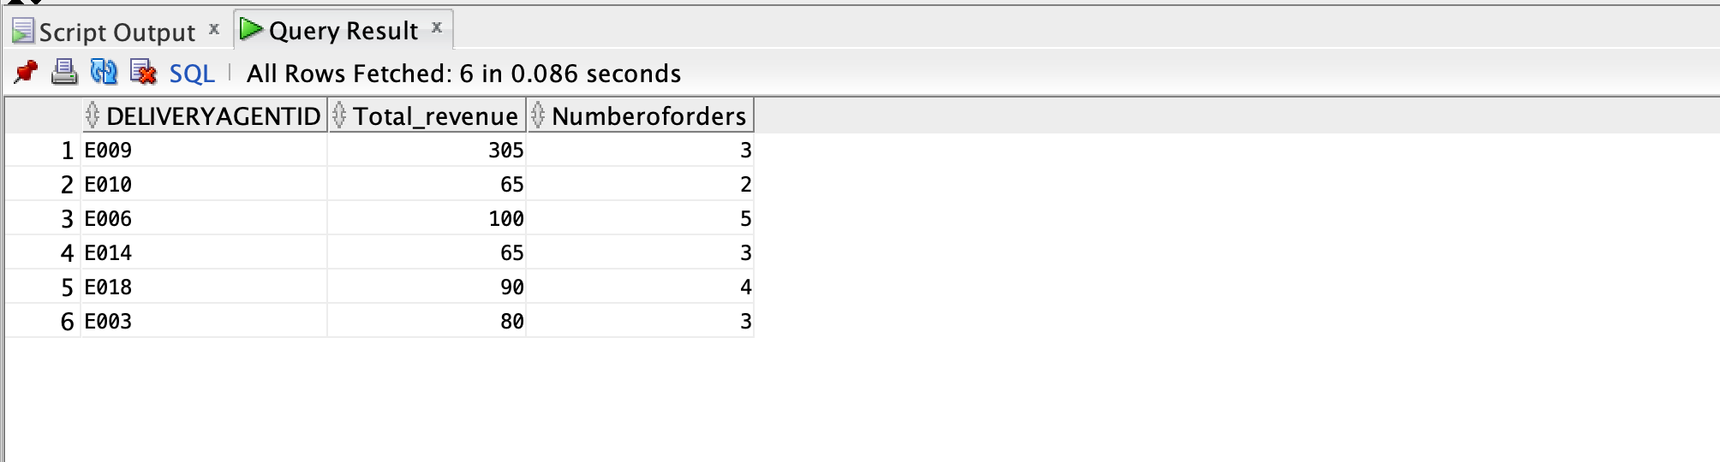

### Query 5(View Restaurant Category)

Categorization of restaurants based on the average price of items on their menu. If the average is below $10 then it is a low priced restaurant eles it is a highly priced restaurant.

CREATE OR REPLACE VIEW V_RESTAURANT_CATEGORY AS

SELECT

m.restaurantid,

r.restaurantname,

CASE

WHEN AVG(m.itemprice) <= 10 THEN

'Low Priced Restaurant'

ELSE

'High Priced Restaurant'

END AS "Restaurant_Category"

FROM

restaurant r

INNER JOIN menu_items m ON m.restaurantid = r.restaurantid

GROUP BY

m.restaurantid,

r.restaurantname

ORDER BY

m.restaurantid

WITH CHECK OPTION;

*Output:*

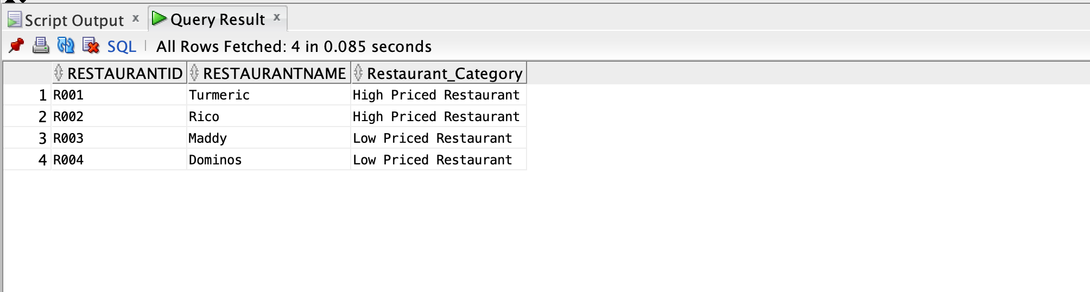

### Query 6 (Department Statistics)

Display department - wise average salary, highest salary in the department, lowest salary in the department.

ASSUMPTION: All of them are full-time employees who work 5 days a week and 40 hours per week.

CREATE OR REPLACE VIEW V_DEPARTMENT_STAT AS

SELECT

d.deptid,

AVG(p.payrate * 40 * 4) AS "Average Salary",

MAX(p.payrate * 40 * 4) AS "Highest Salary",

MIN(p.payrate * 40 * 4) AS "Lowest Salary"

FROM

departments d

JOIN employees e ON d.deptid = e.deptid

JOIN payroll p ON p.employeeid = e.employeeid

GROUP BY

d.deptid

WITH CHECK OPTION;

*Output:*

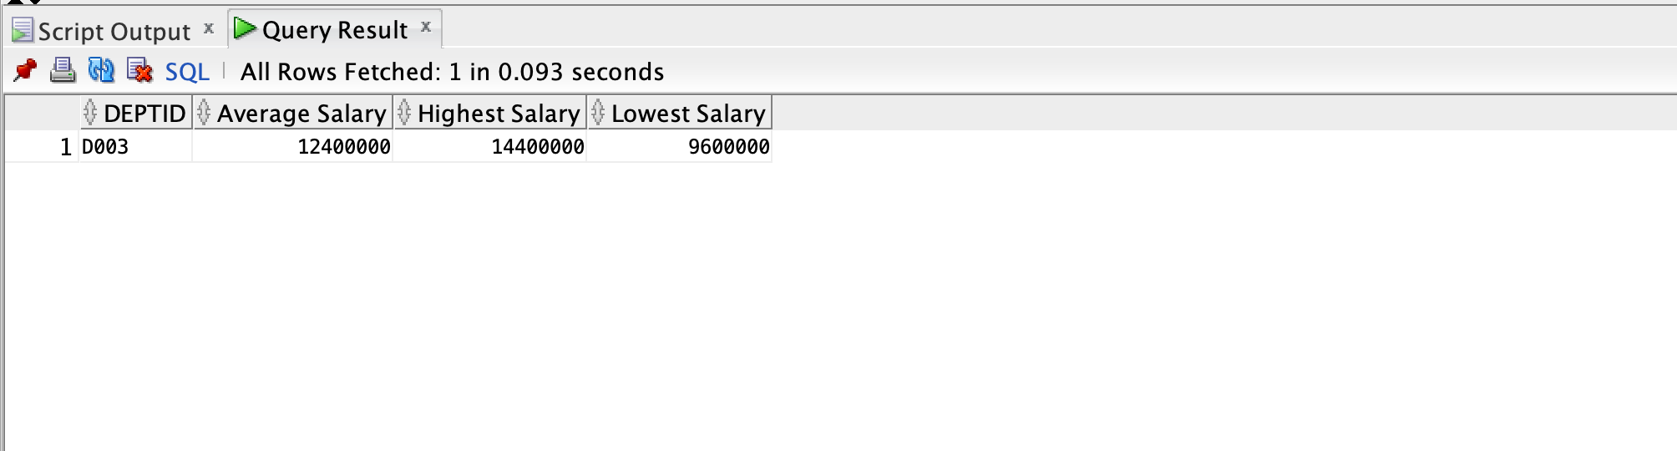

### Query 7(Restaurants Last Order Date)

For each restaurant in the database, display the more recent order date for that restaurant.

CREATE OR REPLACE VIEW v_restaurant_last_order_date AS

WITH ro AS (

SELECT

r.restaurantname,

o.orderdate,

ROW_NUMBER()

OVER(PARTITION BY r.restaurantid

ORDER BY

o.orderdate DESC

) AS rown

FROM

restaurant r

JOIN menu_items m ON m.restaurantid = r.restaurantid

JOIN order_details od ON od.itemid = m.itemid

JOIN orders o ON o.orderid = od.orderid

)

SELECT

restaurantname,

orderdate AS "Last_Order_Date"

FROM

ro

WHERE

rown = 1

WITH CHECK OPTION;

*Output:*

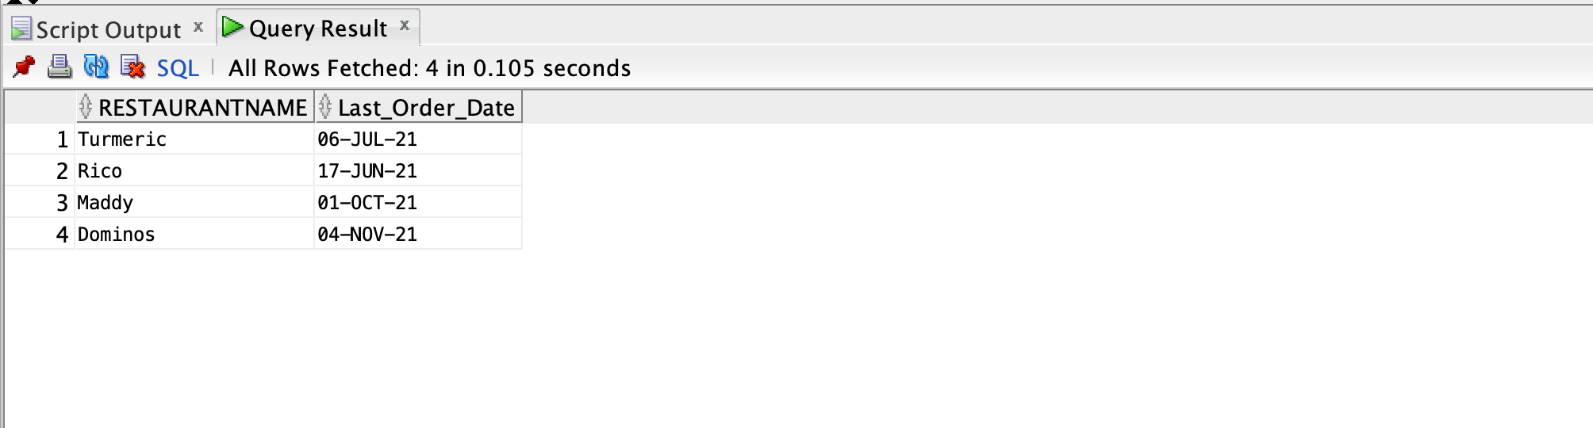

### Query 8 (View Item Types)

Display restaurantId, Restaurant Name, Number of high priced items, total revenue generated from high priced items, number of low priced items, revenue generated from low priced items , percentage revenue generated from high priced items.

Item price greater than $10 - High Priced Item

Item Price less than $10 - Low Priced Item

CREATE OR REPLACE VIEW V_ITEM_TYPE

AS

WITH item_type as(

select

m.restaurantid,

r.restaurantname as "Restaurant_Name",

count(distinct case when m.itemprice> 10 then m.itemid end) as "Numb_of_High_Priced_items",

to_char(sum

(case when m.itemprice> 10 then (m.itemprice * od.quantity) end),

'$999,999.99') as "Revenue_from_high_Priced_items",

count(distinct case when m.itemprice< 10 then m.itemid end) as "Numb_of_Low_Priced_items",

to_char(sum

(case when m.itemprice < 10 then (m.itemprice * od.quantity) end),

'$999,999.99') as "Revenue_from_low_Priced_items",

to_char(sum

(case when m.itemprice> 10 then (m.itemprice * od.quantity) end)

/sum(m.itemprice * od.quantity) * 100, '999,999.99')

as "Prcnt_Revenue_high_price_item"

from restaurant r

inner join menu_items m on m.restaurantid = r.restaurantid

inner join order_details od on od.itemid =m.itemid

group by m.restaurantid, r.restaurantname

order by m.restaurantid

)

select

"Restaurant_Name",

nvl("Numb_of_High_Priced_items",0) as "High_Priced",

nvl("Revenue_from_high_Priced_items",0) as "High_Revenue_Price",

nvl("Numb_of_Low_Priced_items",0) as "Low_Priced",

nvl("Revenue_from_low_Priced_items",0) as "Low_Revenue_Price",

nvl("Prcnt_Revenue_high_price_item",0) || '%' as "Percent_High_price_Revenue"

from item_type

WITH CHECK OPTION;

*Output:*

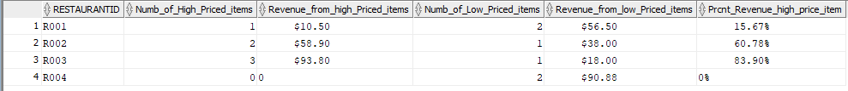

### Query 9 (View Customer Stats)

Select the total number of orders and the total amount spent by each customer throughout their tenure as a customer.

CREATE OR REPLACE VIEW V_Cust_Stat

AS

with cte1 as(

select (c.fname || ' ' || c.lname) as names,

c.customerid,

count(distinct o.orderid) as totalorders,

nvl(sum(quantity * m.itemprice),'0') as totalamountspent

from customers c

left join orders o on c.customerid=o.customerid

left join order_details od on od.orderid=o.orderid

left join menu_items m on m.itemid=od.itemid

group by (fname || ' '||lname),c.customerid

),

cte2 as(

select c.customerid--, m.itemid as itemidi

from customers c

left join orders o on c.customerid=o.customerid

left join order_details od on od.orderid=o.orderid

left join menu_items m on m.itemid=od.itemid

group by c.customerid

--group by c.customerid

)

select cte1.customerid, totalorders, totalamountspent

from cte1 join cte2 on cte1.customerid = cte2.customerid

where cte1.customerid=cte2.customerid;

*Output:*

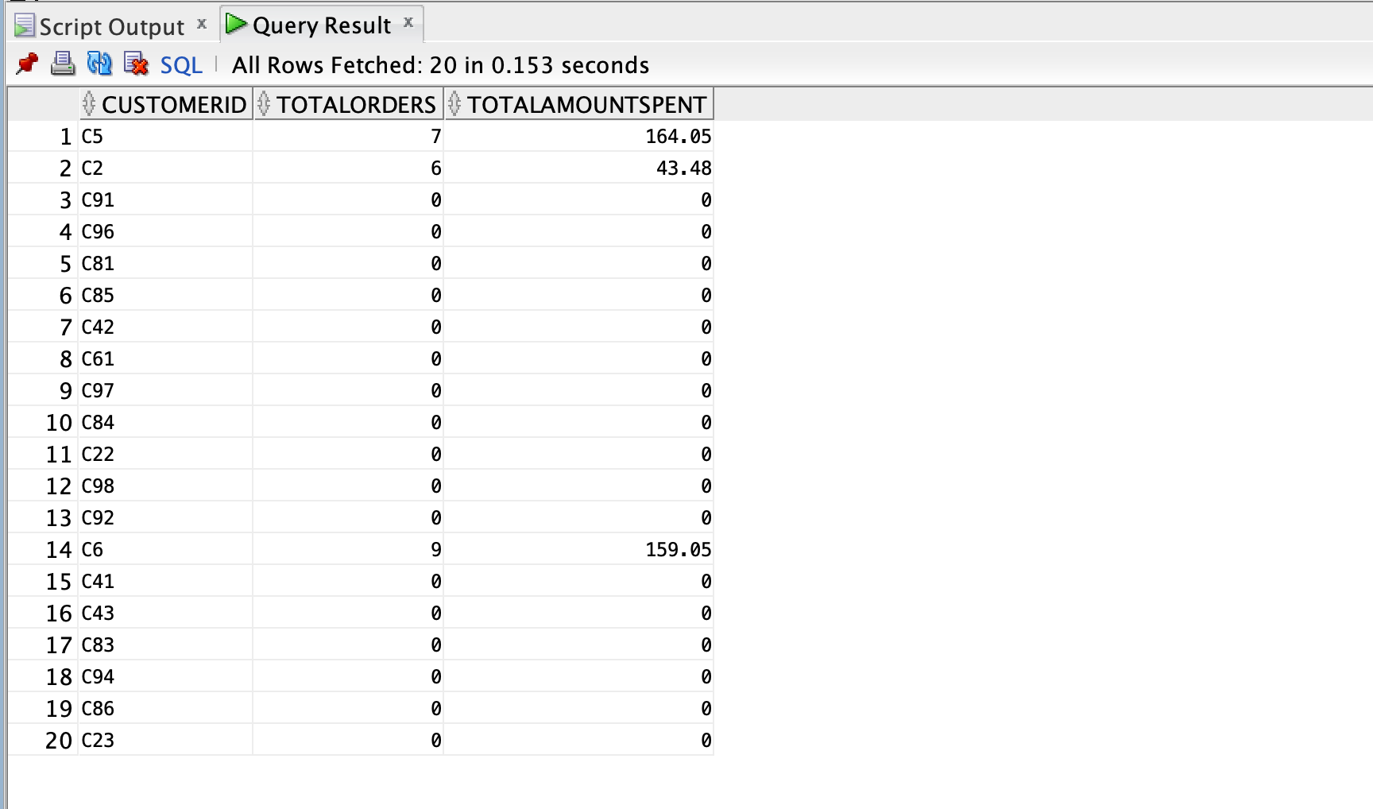

### Query 10(View Most Ordered Items)

Identify the most ordered item per restaurant to help make better decisions.

CREATE OR REPLACE VIEW V_MOST_ORDERED_DISH (ItemID, RestaurantID, ItemName, ItemCount)

AS

with PI as (select od.itemID, m.itemname, sum(quantity) as "Item count"

from ORDER_DETAILS od join MENU_ITEMS m on od.itemID = m.itemID

group by od.itemID, m.itemname

order by "Item count" desc)

select PI.itemID, m.restaurantID, PI.itemName, "Item count"

from MENU_ITEMS m join PI on m.itemID = PI.itemID

order by "Item count" desc

WITH CHECK OPTION;

*Output:*

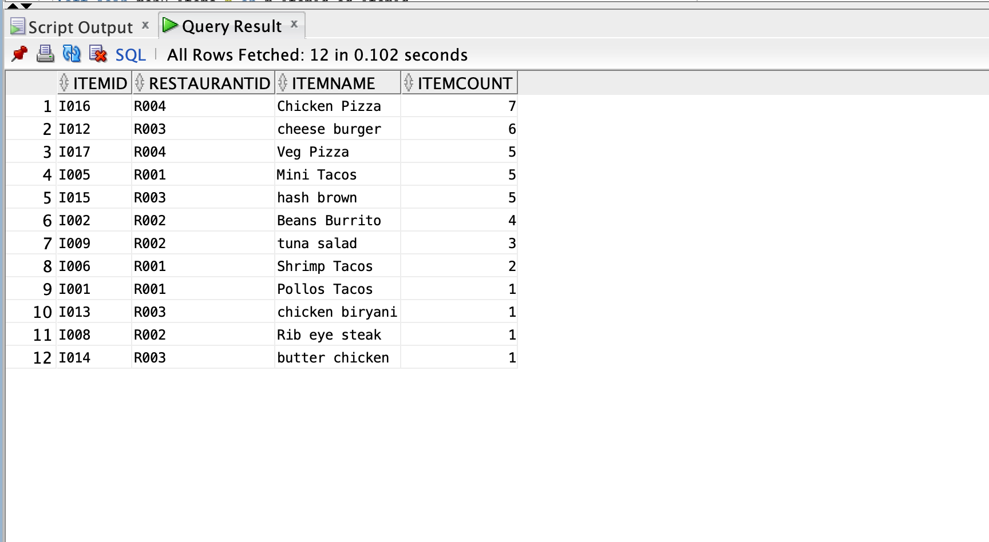

### Query 11(View Quarter wise Revenue)

Display revenue generated by each restaurant(R001,R002,R003) in each quarter.

CREATE OR REPLACE VIEW v_quarter_revenue AS

WITH q AS (

SELECT

CASE

WHEN EXTRACT(MONTH FROM orderdate) IN ( 1, 2, 3 ) THEN

'Q1'

WHEN EXTRACT(MONTH FROM orderdate) IN ( 4, 5, 6 ) THEN

'Q2'

WHEN EXTRACT(MONTH FROM orderdate) IN ( 7, 8, 9 ) THEN

'Q3'

ELSE

'Q4'

END AS quarters,

coalesce((m.itemprice * od.quantity), 0) AS sales,

r.restaurantid

FROM

orders o

JOIN order_details od ON od.orderid = o.orderid

JOIN menu_items m ON od.itemid = m.itemid

JOIN restaurant r ON r.restaurantid = m.restaurantid

)

SELECT

quarters,

to_char(coalesce("'R001'_NumOrders", 0), '$999,999.99') AS "Sales_R001",

to_char(coalesce("'R002'_NumOrders", 0), '$999,999.99') AS "Sales_R002",

to_char(coalesce("'R003'_NumOrders", 0), '$999,999.99') AS "Sales_R003"

FROM

q e PIVOT (

SUM ( sales )

AS "NumOrders"

FOR restaurantid

IN ( 'R001',

'R002',

'R003' )

)

GROUP BY

quarters,

"'R001'_NumOrders",

"'R002'_NumOrders",

"'R003'_NumOrders"

ORDER BY

quarters

WITH CHECK OPTION;

*Output:*

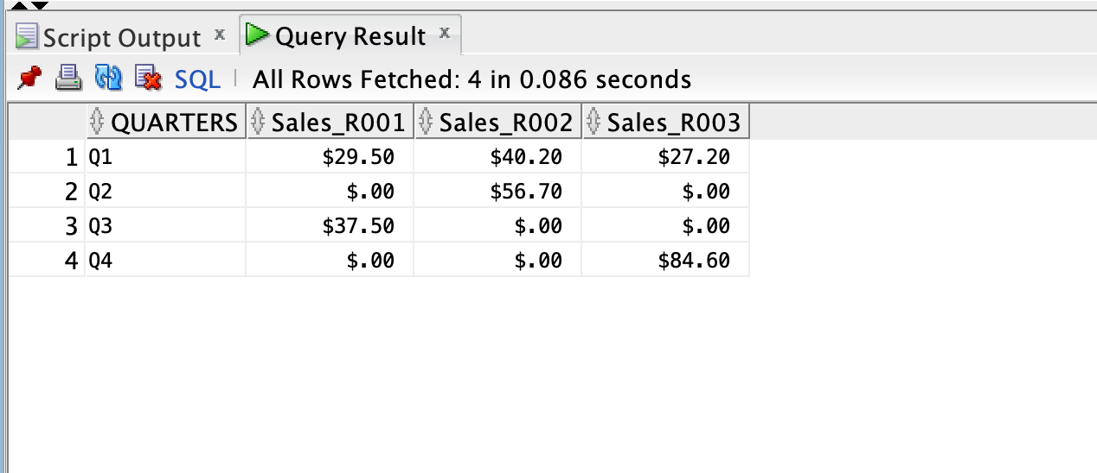

### 

### Query 12(View Popular Restaurants)

Rank the restaurants based on the total revenue generated by restaurants - with the highest revenue generated restaurant ranked number 1 and so on under ‘Popular restaurant.’

CREATE OR REPLACE VIEW v_popular_restaurant AS

WITH rank_revenue AS (

SELECT

mi.restaurantid,

SUM(od.totalprice) AS "Revenue"

FROM

order_details od

JOIN menu_items mi ON od.itemid = mi.itemid

GROUP BY

mi.restaurantid

)

SELECT

rr.restaurantid,

rr."Revenue",

RANK()

OVER(

ORDER BY

"Revenue" DESC

) popularity

FROM

rank_revenue rr

ORDER BY

popularity

WITH CHECK OPTION;

*Output:*

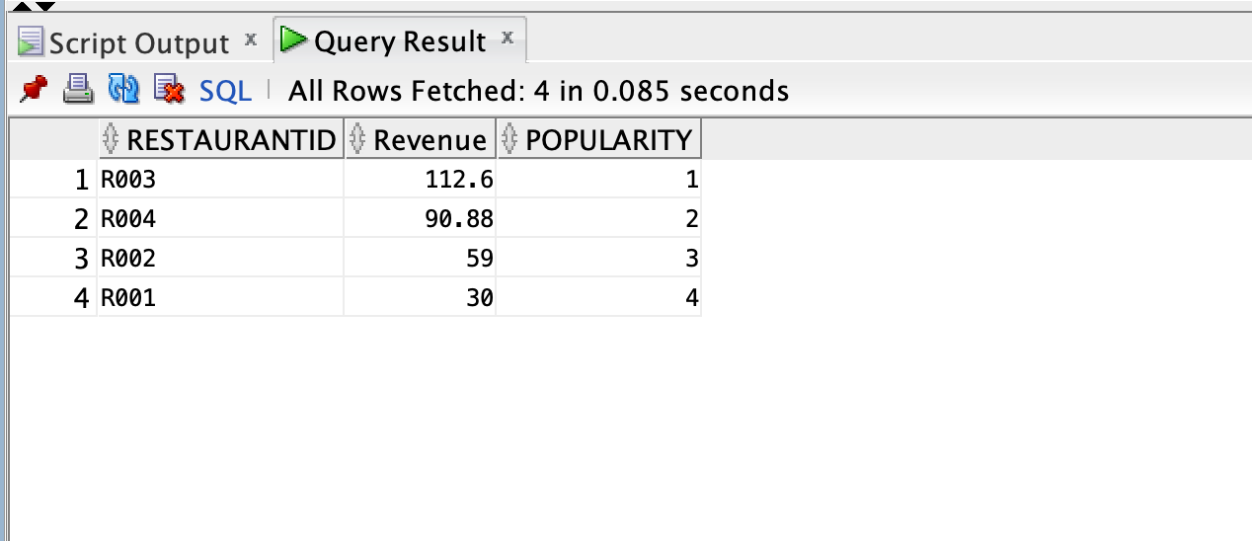

## Trigger and Procedures

### Trigger 1

This trigger is used to dynamically create or populate the total price of an order based on the unit price of each item in the order and the quantity of each item. This trigger is fired automatically before the insert or update of the quantity column in the order details table. The total amount is calculated by multiplying the unit price and the quantity for an item and the resultant amount is populated back in the table.

Create trigger trigger_total_price

before insert or update of quantity on ORDER_DETAILS FOR each row

Declare

v_quantity ORDER_DETAILS.quantity%type;

v_itemPrice MENU_ITEMS.itemPrice%type;

v_itemID ORDER_DETAILS.itemID%type;

v_total_price ORDER_DETAILS.totalPrice%type;

v_orderID ORDER_DETAILS.orderID%type;

BEGIN

v_quantity:= :new.quantity ;

v_itemID:= :new.itemID;

v_orderID:= :new.orderID;

select itemPrice into v_itemPrice from MENU_ITEMS m where m.itemID = v_itemID;

v_total_price:= (v_quantity * v_itemPrice);

:new.totalPrice := v_total_price;

end;

/

### Trigger 2

Generates the trigger for Number of trips filed on the EMPLOYEES_DELIVERY_AGENT table . Every time a new order is generated, a delivery agent ID is assigned to it. We increment the Total number of trips for that rider.

CREATE TRIGGER increment_rider_trips AFTER

INSERT ON deliveryservices

FOR EACH ROW

DECLARE

v_deliveryagentid employees_delivery_agent.deliveryagentid%TYPE;

BEGIN

v_deliveryagentid := :new.deliveryagentid;

UPDATE employees_delivery_agent

SET

numberoftrips = numberoftrips + 1

WHERE

deliveryagentid = v_deliveryagentid;

END;

/

### 

### Procedure 1

## 

## User Interface

As per the requirement, a website was set up to provide an online platform for the user to be able to browse their favourite restaurants and place an order for their desired dishes.

The link to the application hosted on AWS is as follows:

<http://ec2-52-27-17-218.us-west-2.compute.amazonaws.com:8080/home>

#### 

#### Welcome Page

The first page that the user sees is the welcome or the login page which provides an option for the user to either log in if they are a returning user or register if they are a new user. There is an additional button to vue summary statistics or special queries which give more insight on the data in store.

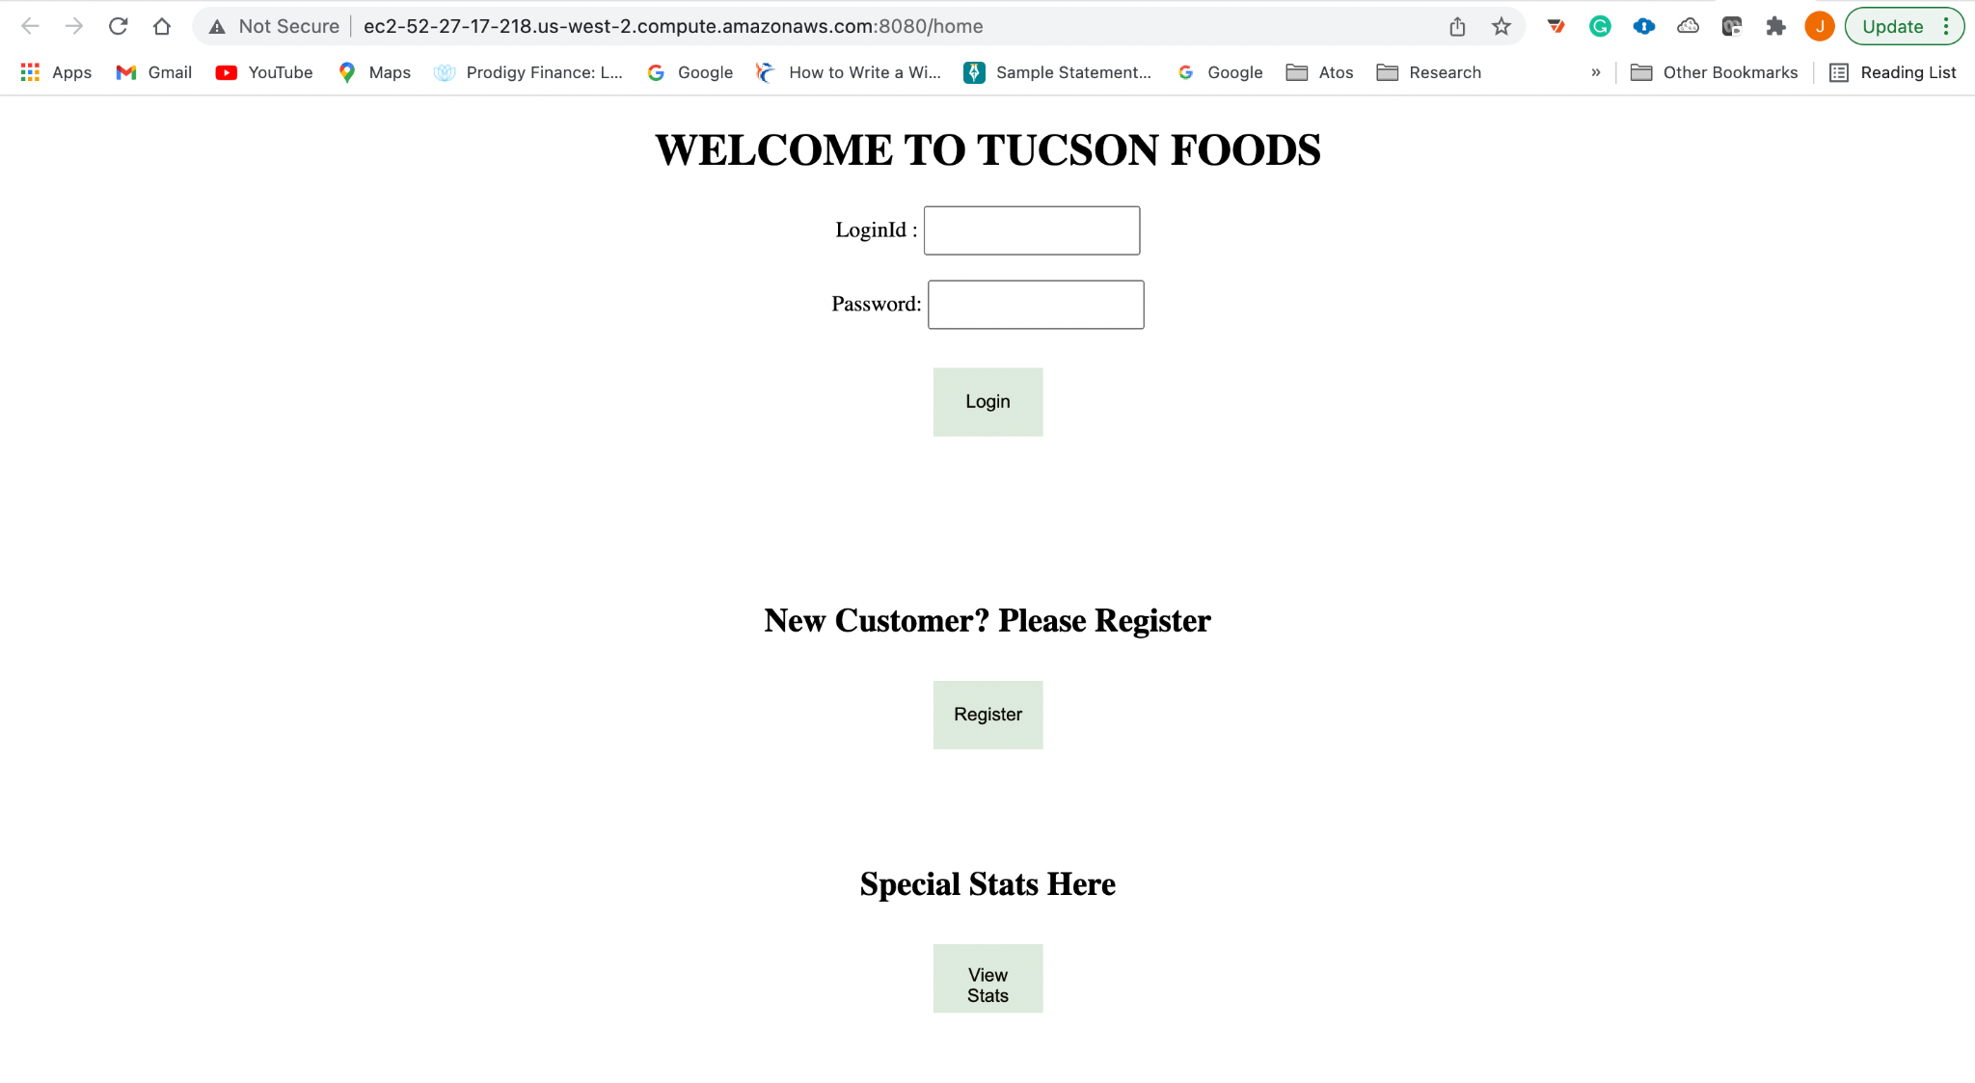

#### Register Page

This page pops up when a new user is trying to register with the system. The user is prompted to enter his or her preferred credentials and enter information for a security question and answer for future recovery of password if required.

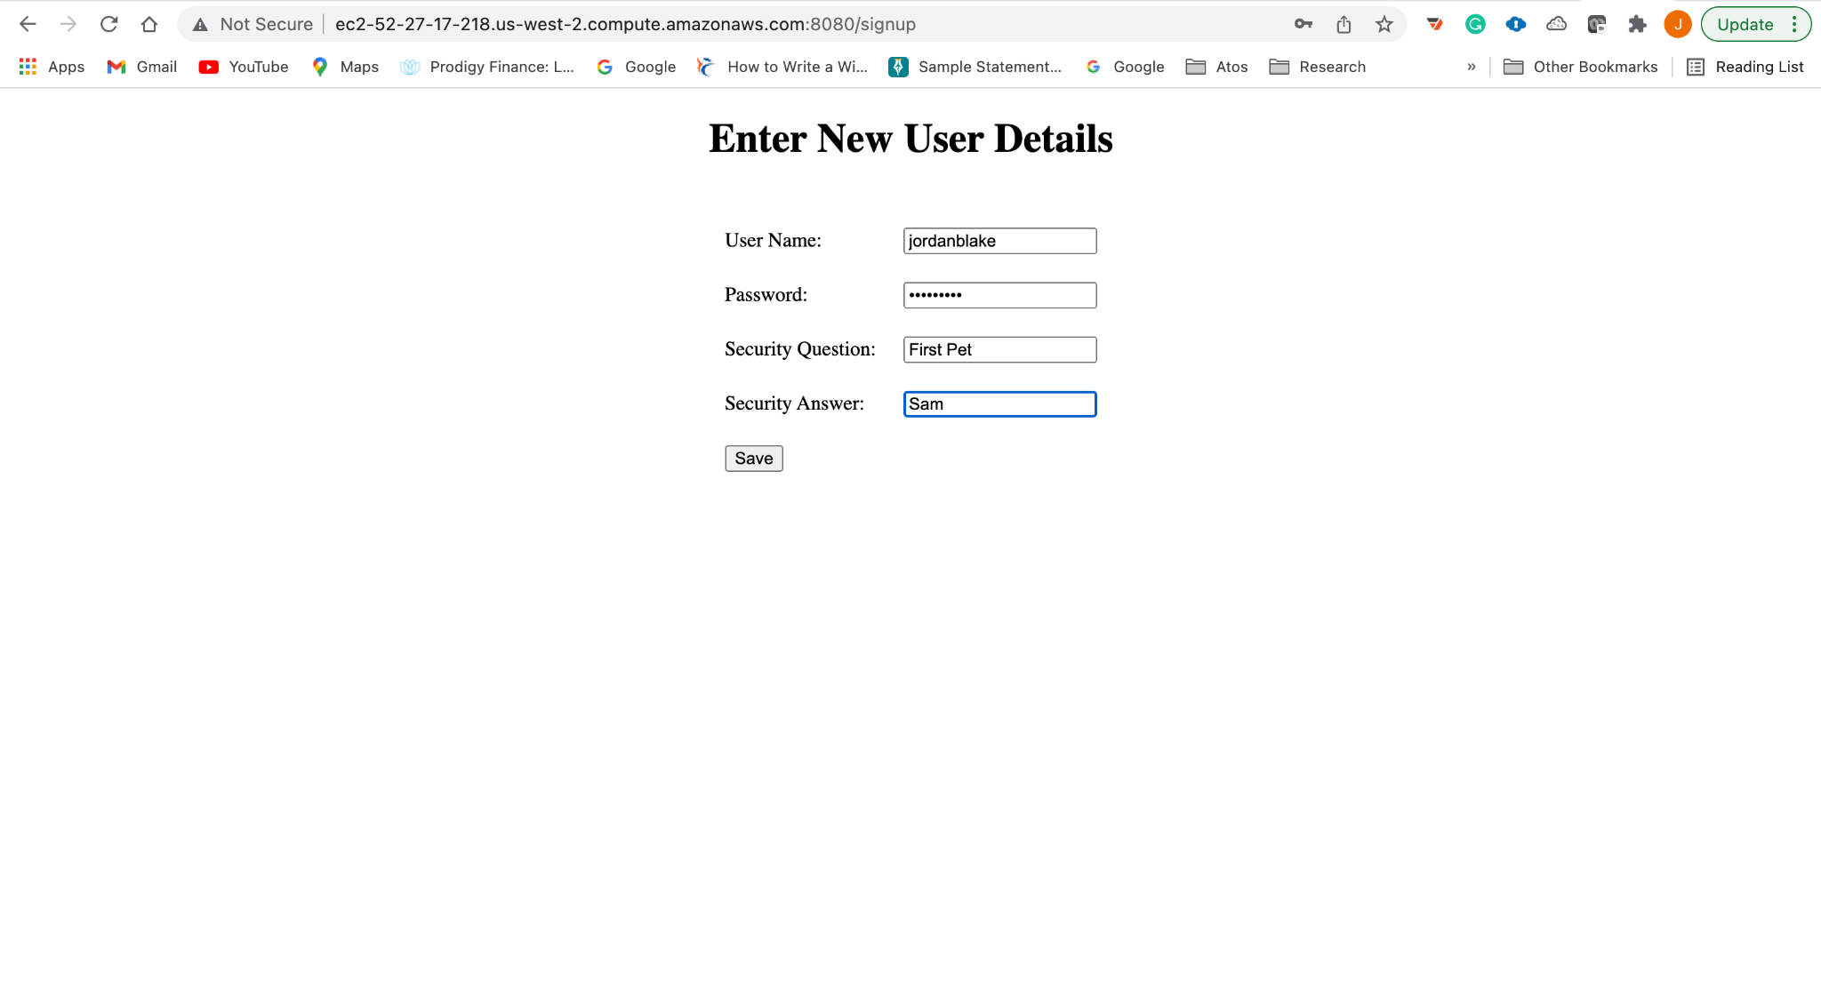

#### User Profile Page

Upon entering the credentials, the user is redirected to a new page which request for additional information to complete their profile.

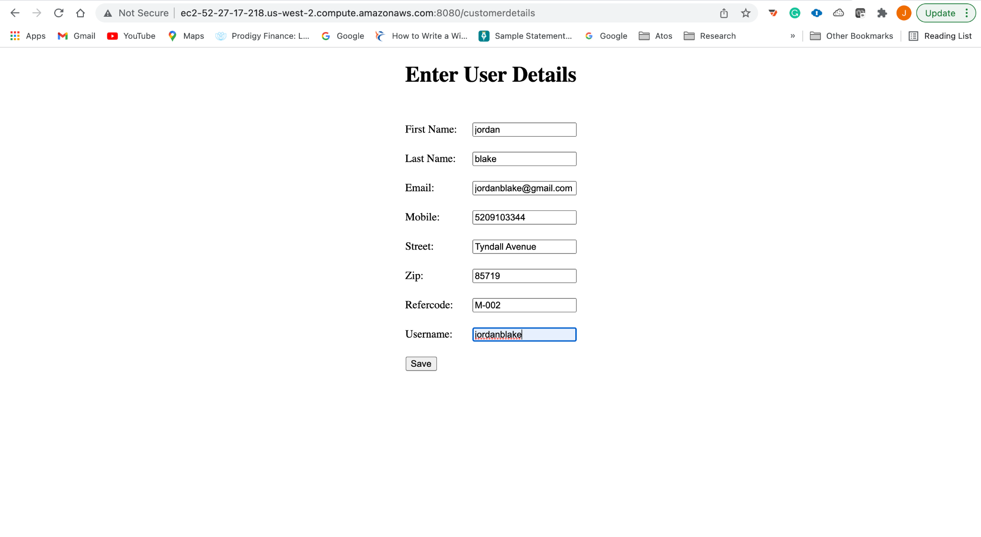

#### Restaurant Page

Once the user has logged into the application either through login in or registration, they are directed to a page that displays the list of restaurants that use Tucson Foods as a delivery service for their restaurants. Each restaurant has a view menu button which displays a menu that is specific to that restaurant.

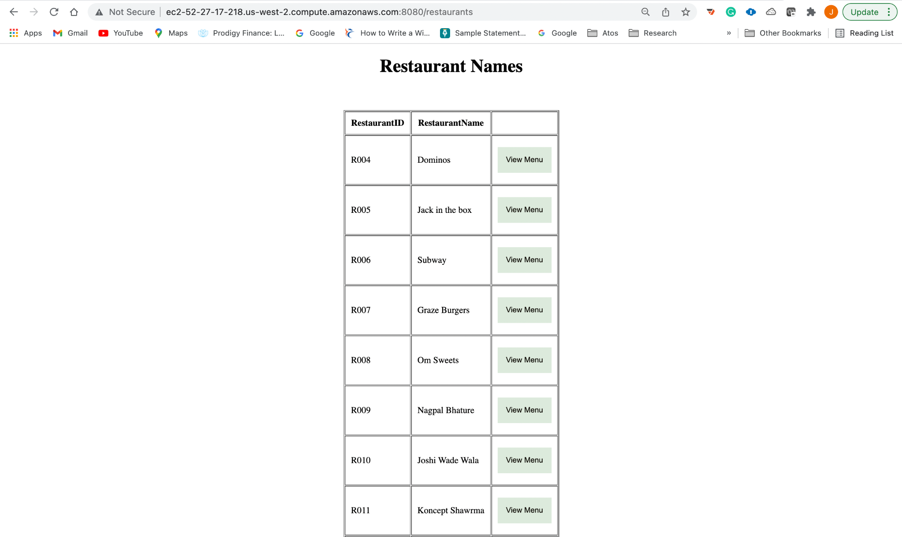

#### Menu Page

When the user wishes to view the menu for a specific restaurant, he or she can simply click the view menu button against that restaurant which will redirect them to a new page which displays the menu items for the selected restaurant.

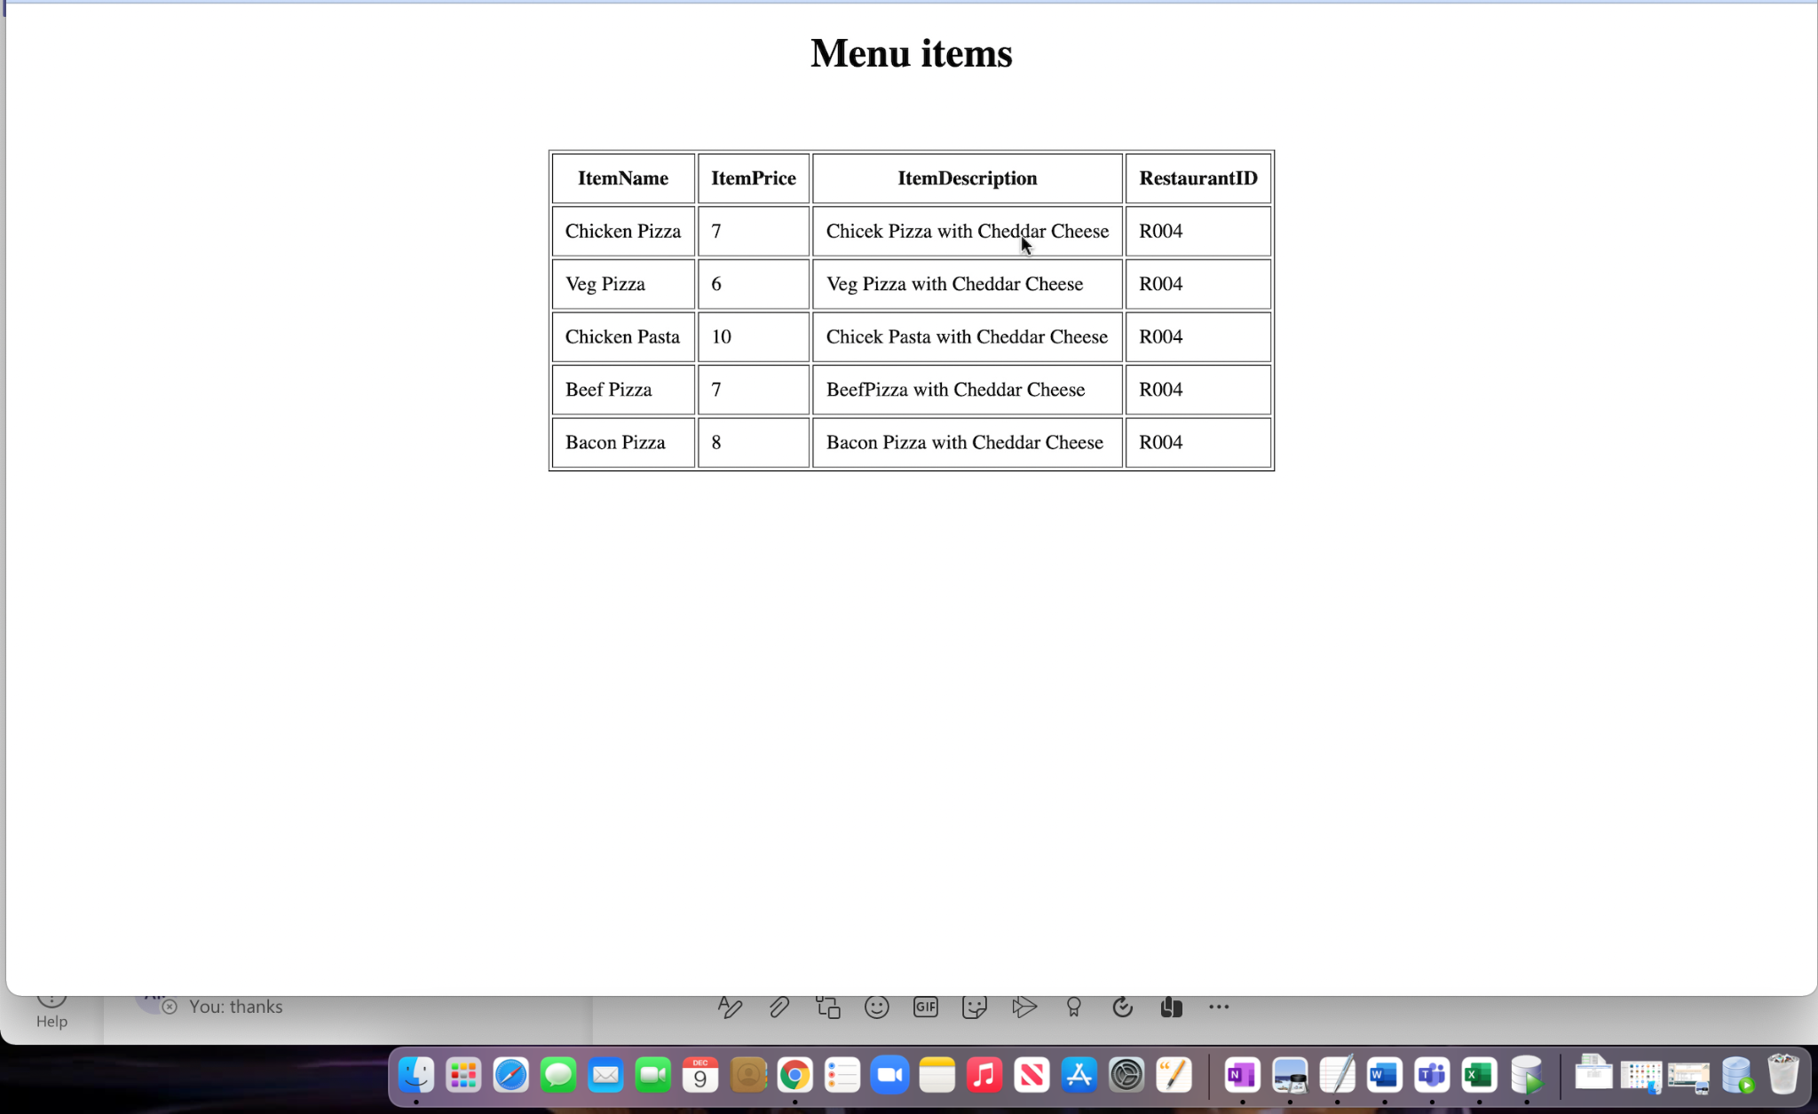

#### Special Queries Page

This page opens when we click the open stats button on the welcome page. The main function of this page is to display the user with multiple options to view different kinds of stats which can help get better insights on the business. This page comprises 12 buttons in total, each of which return results based on some complex query that runs in the background.

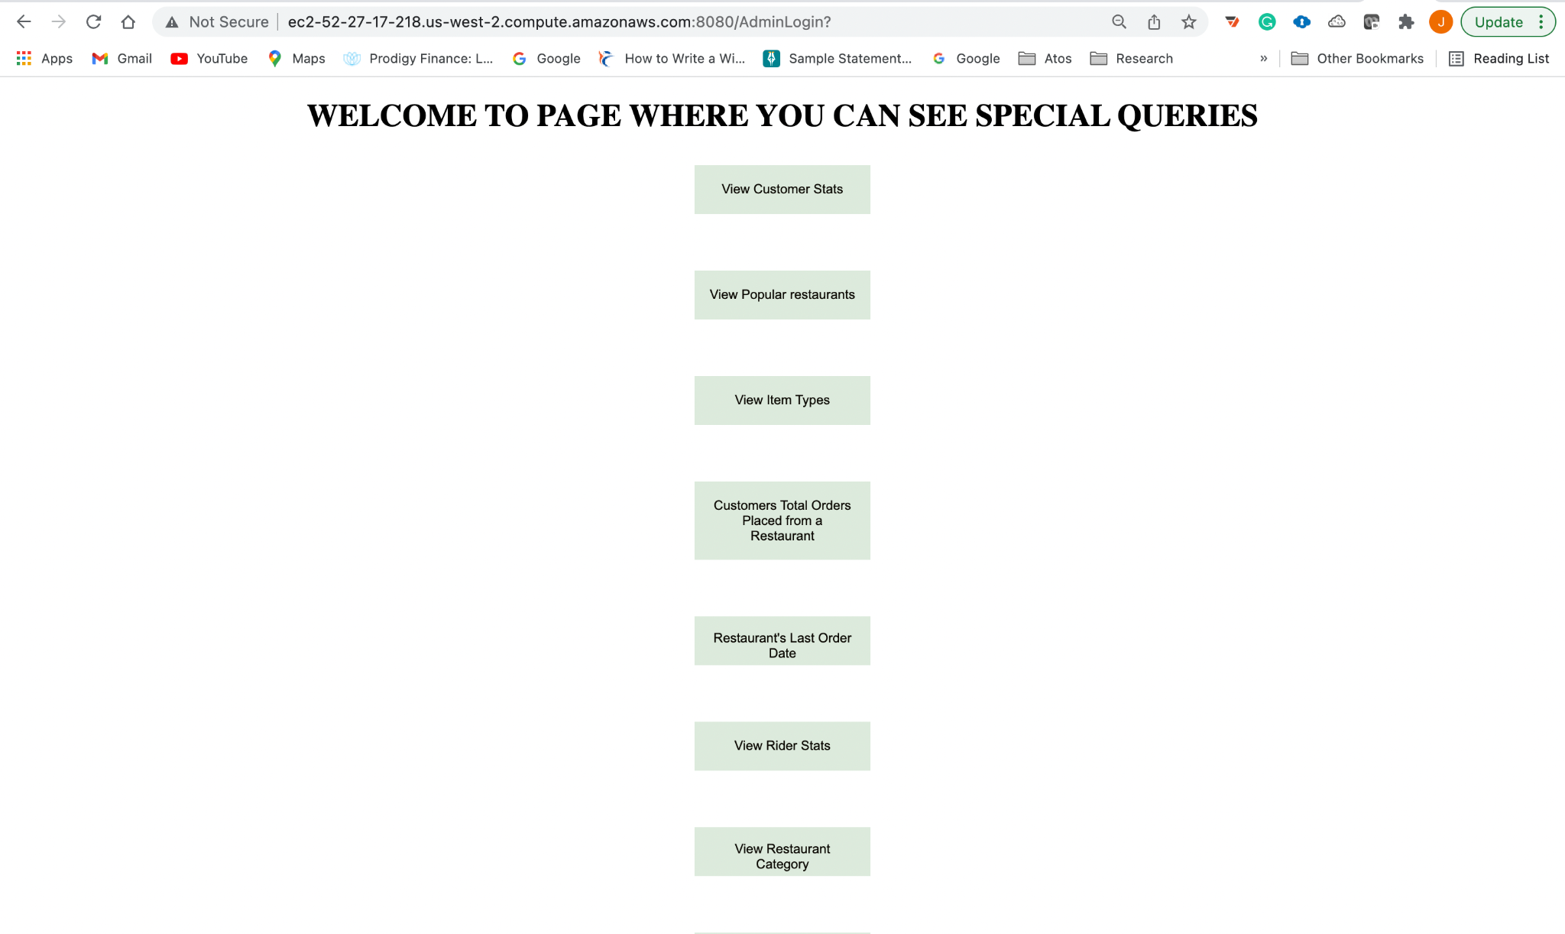

#### Customer Stats Page

On clicking the View Customer Stats button, the user is directed to the following page which displays the statistics of different customers and their total orders and total amount spend.

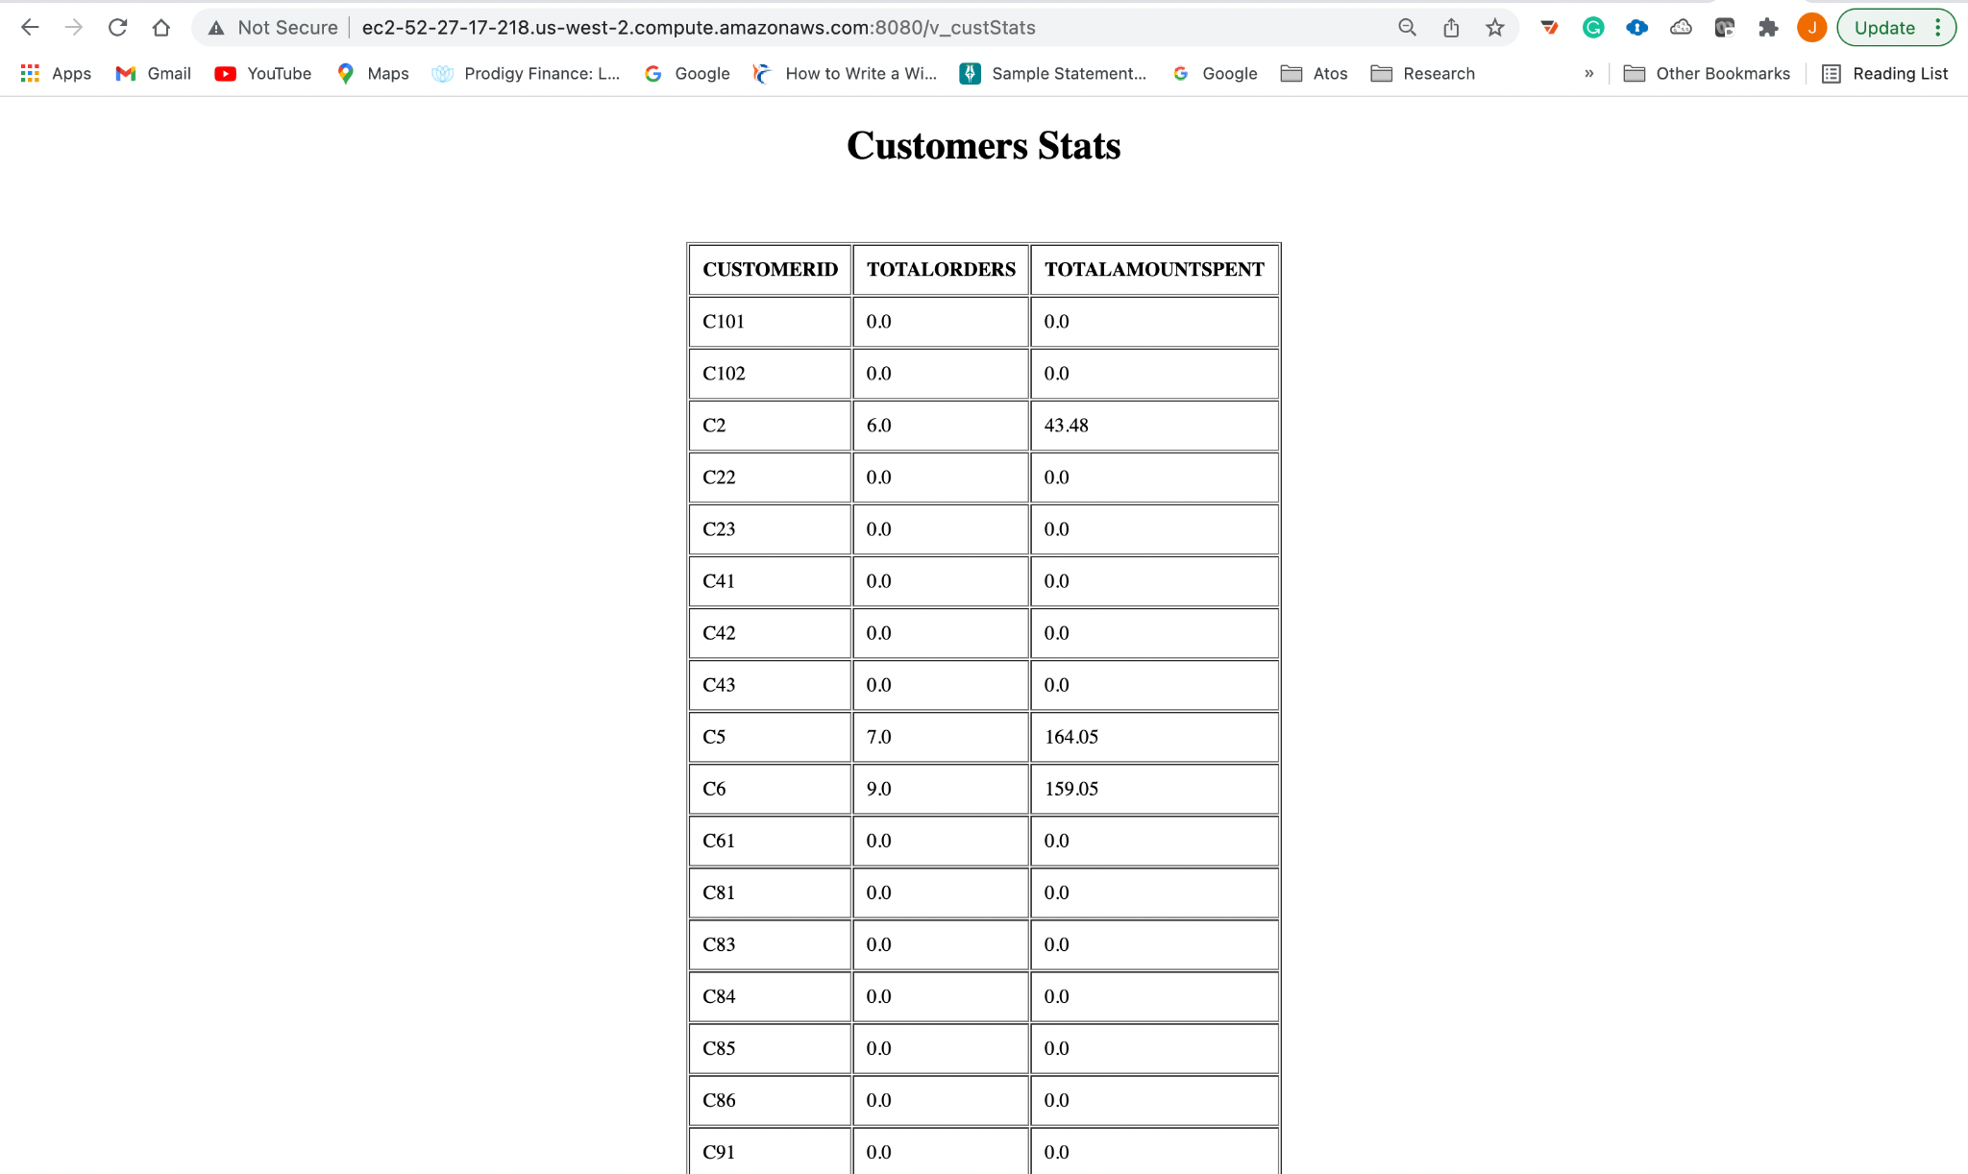

#### Popular Restaurants Page

This page displays information about different restaurants and their popularity based on the rating they receive and the revenue they generated.

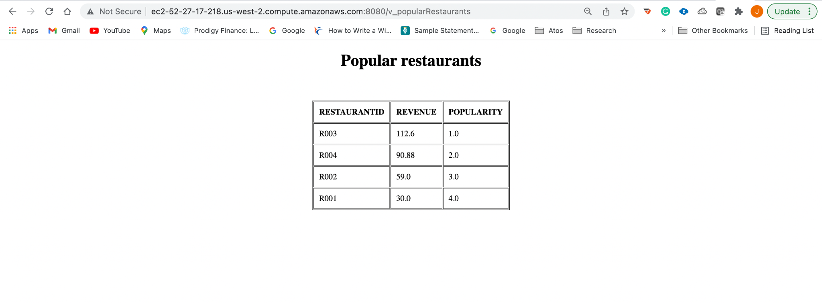

#### Item Types Page

This page displays the number of costly and cheap items in a given restaurant along with percentage of high price revenue.

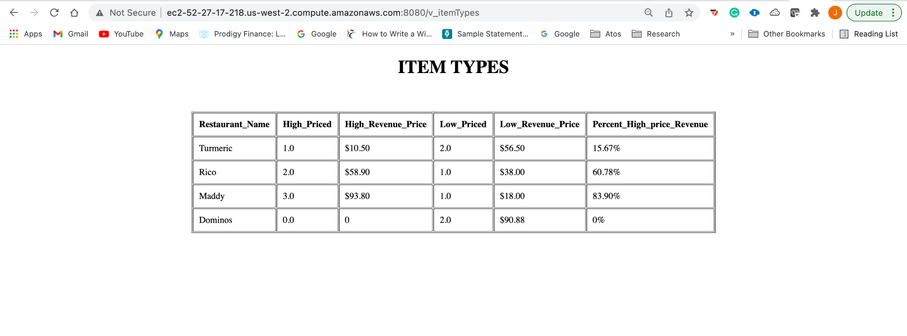

#### Customers Total Order from restaurant page

This page displays the total number of orders placed by a customer for a restaurant.

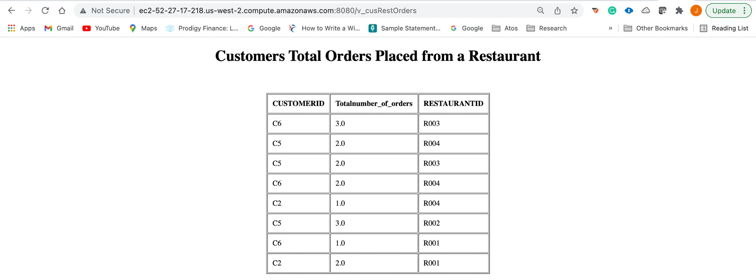

#### Restaurant last Order Page

This page displays the date when the latest order was placed for a given restaurant.

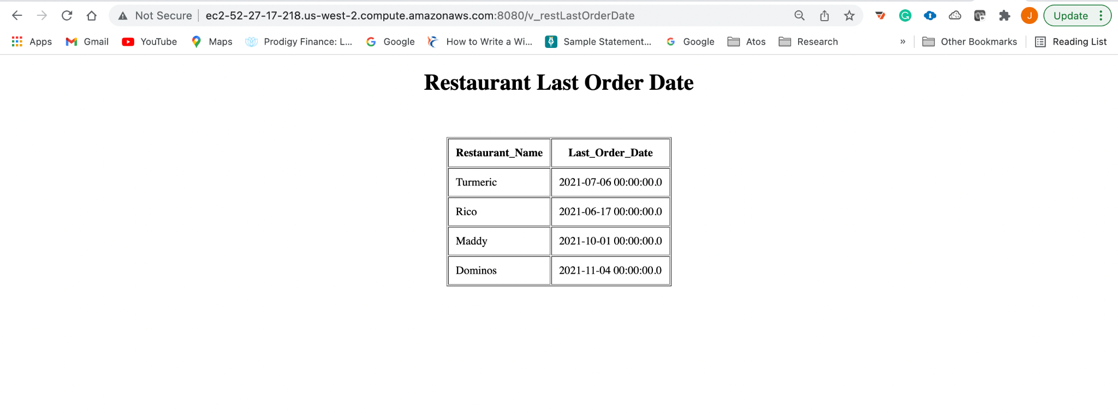

#### Rider Stats Page

This page displays total revenue generated by delivering the orders and number of orders the rider took

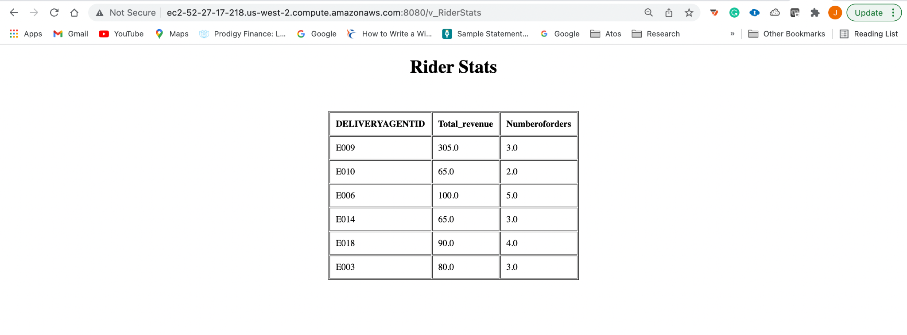

#### Restaurant Category

This page shows the category of the restaurant into high priced and low priced restaurants

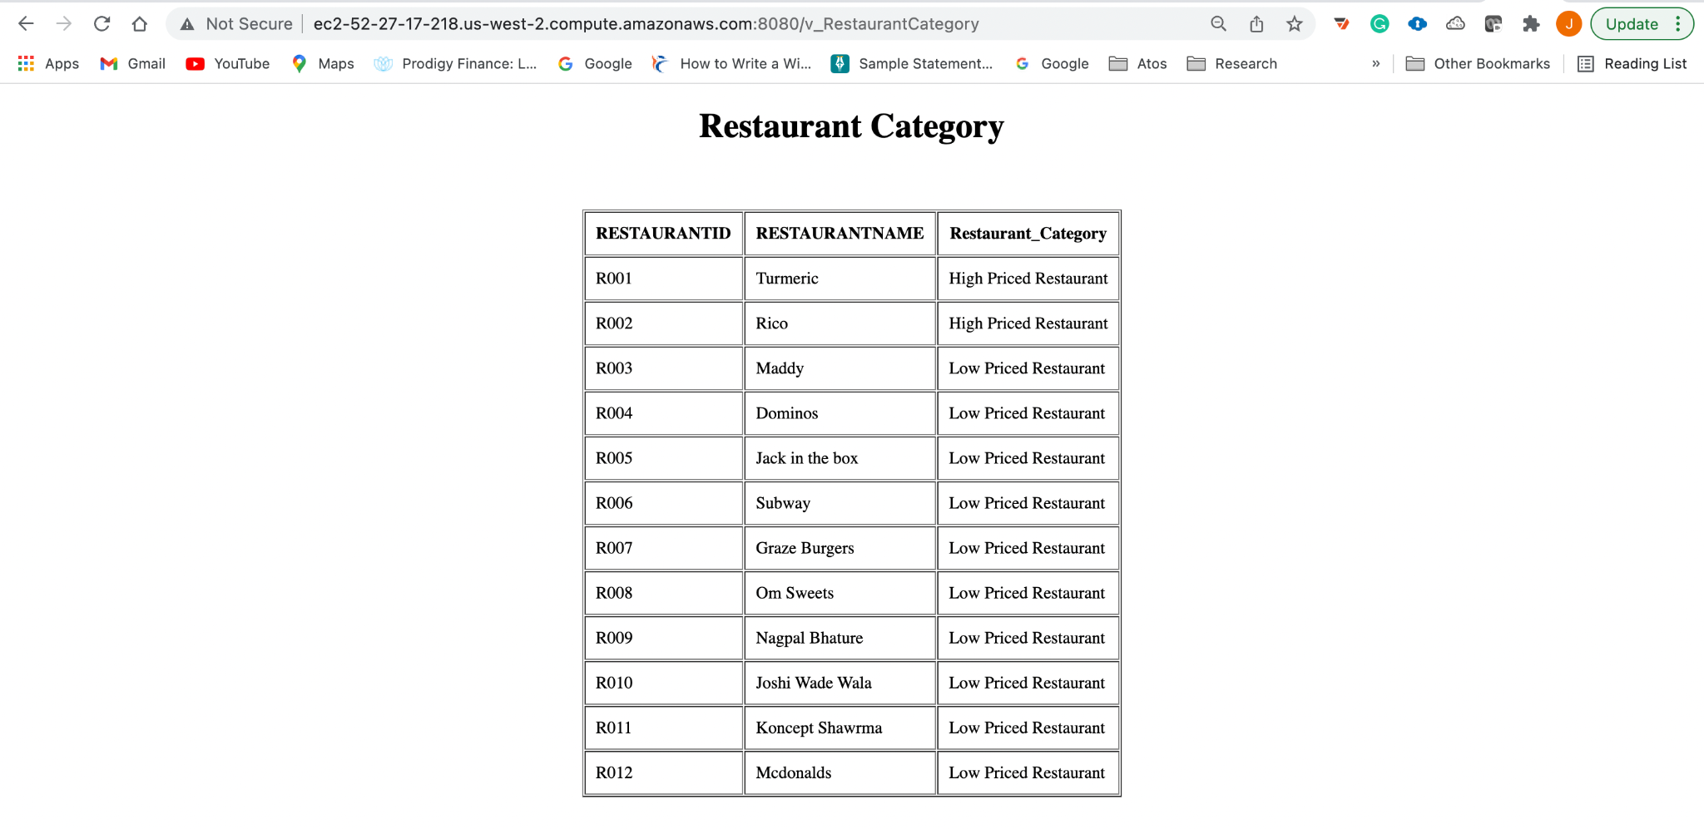

#### Order Stats Page

This page shows the monthly orders that have taken place. With stats for a week ago, the previous day, and weekly and daily change that has happened. This helps businesses to know the busiest days and allocate resources accordingly.

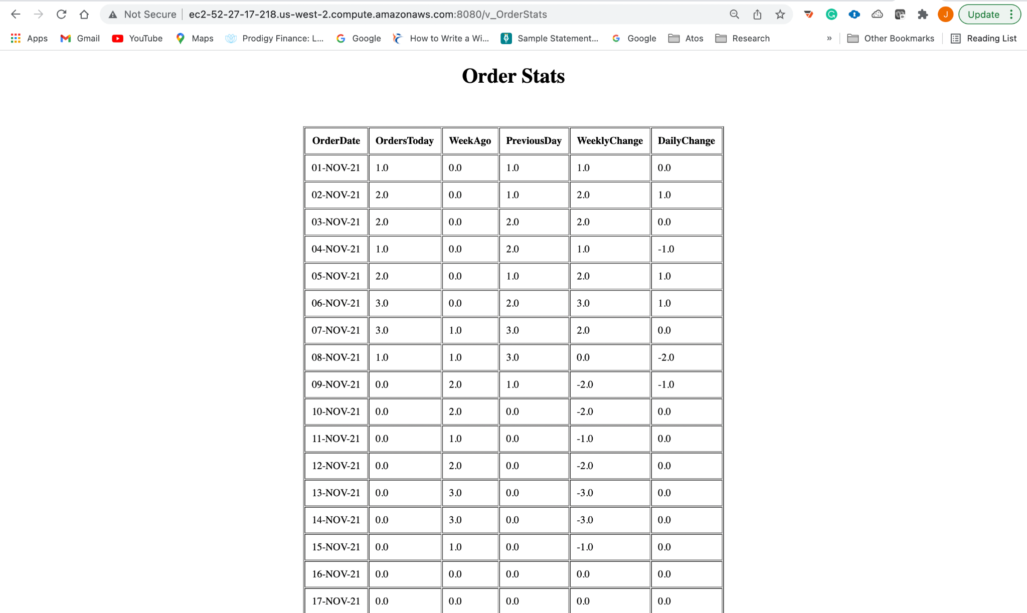

#### Most Ordered Items Page

This page displays the most ordered orders and the restaurant they are associated with.

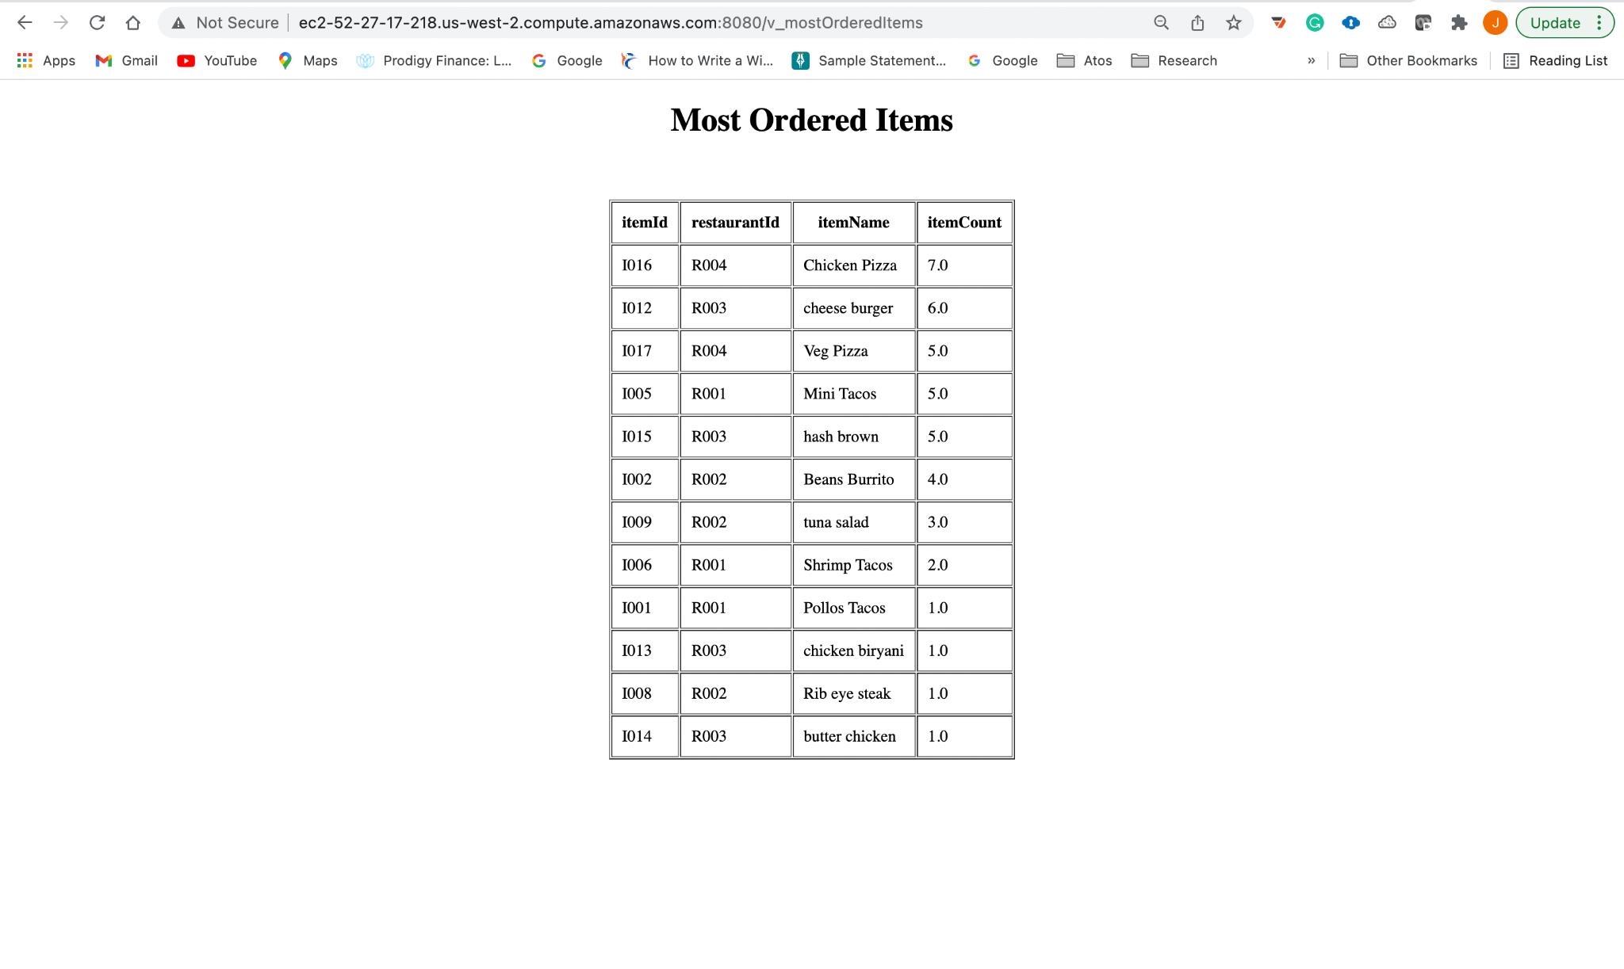

#### Rider Ranking Page

This page displays rider rank based on total number of rides and rating they have

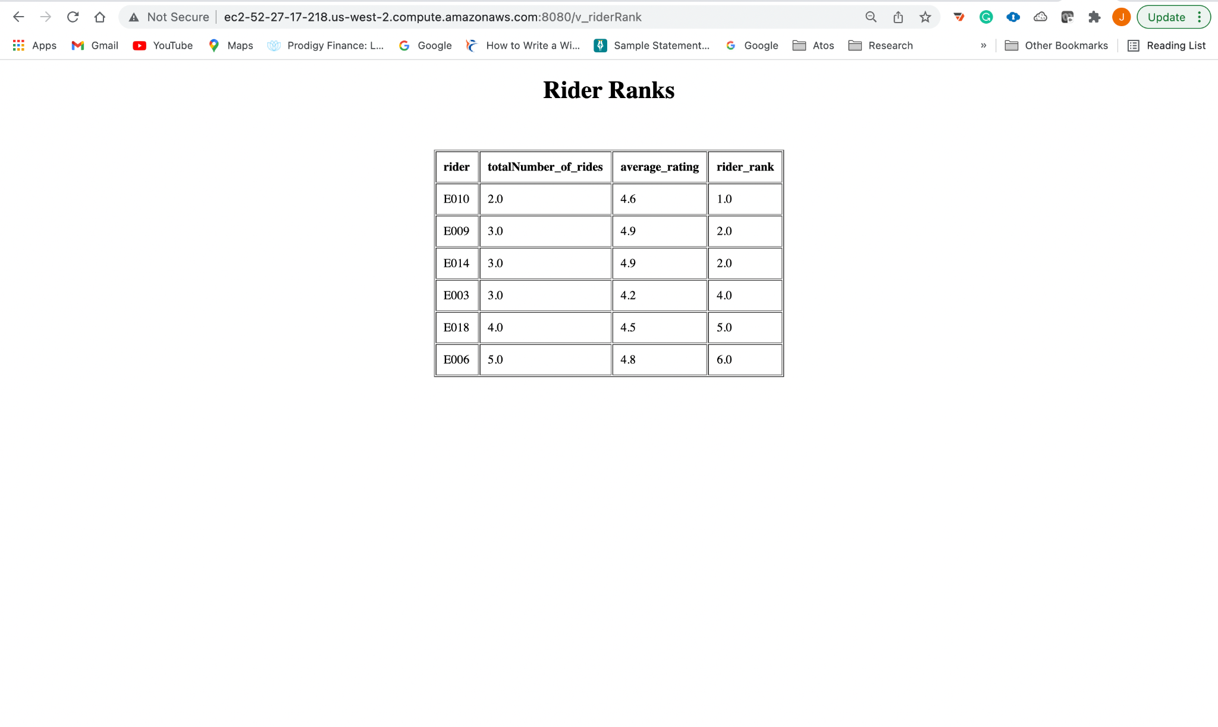

#### Quarter Wise Revenue Page

This page displays the sales for different restaurants for every quarter .

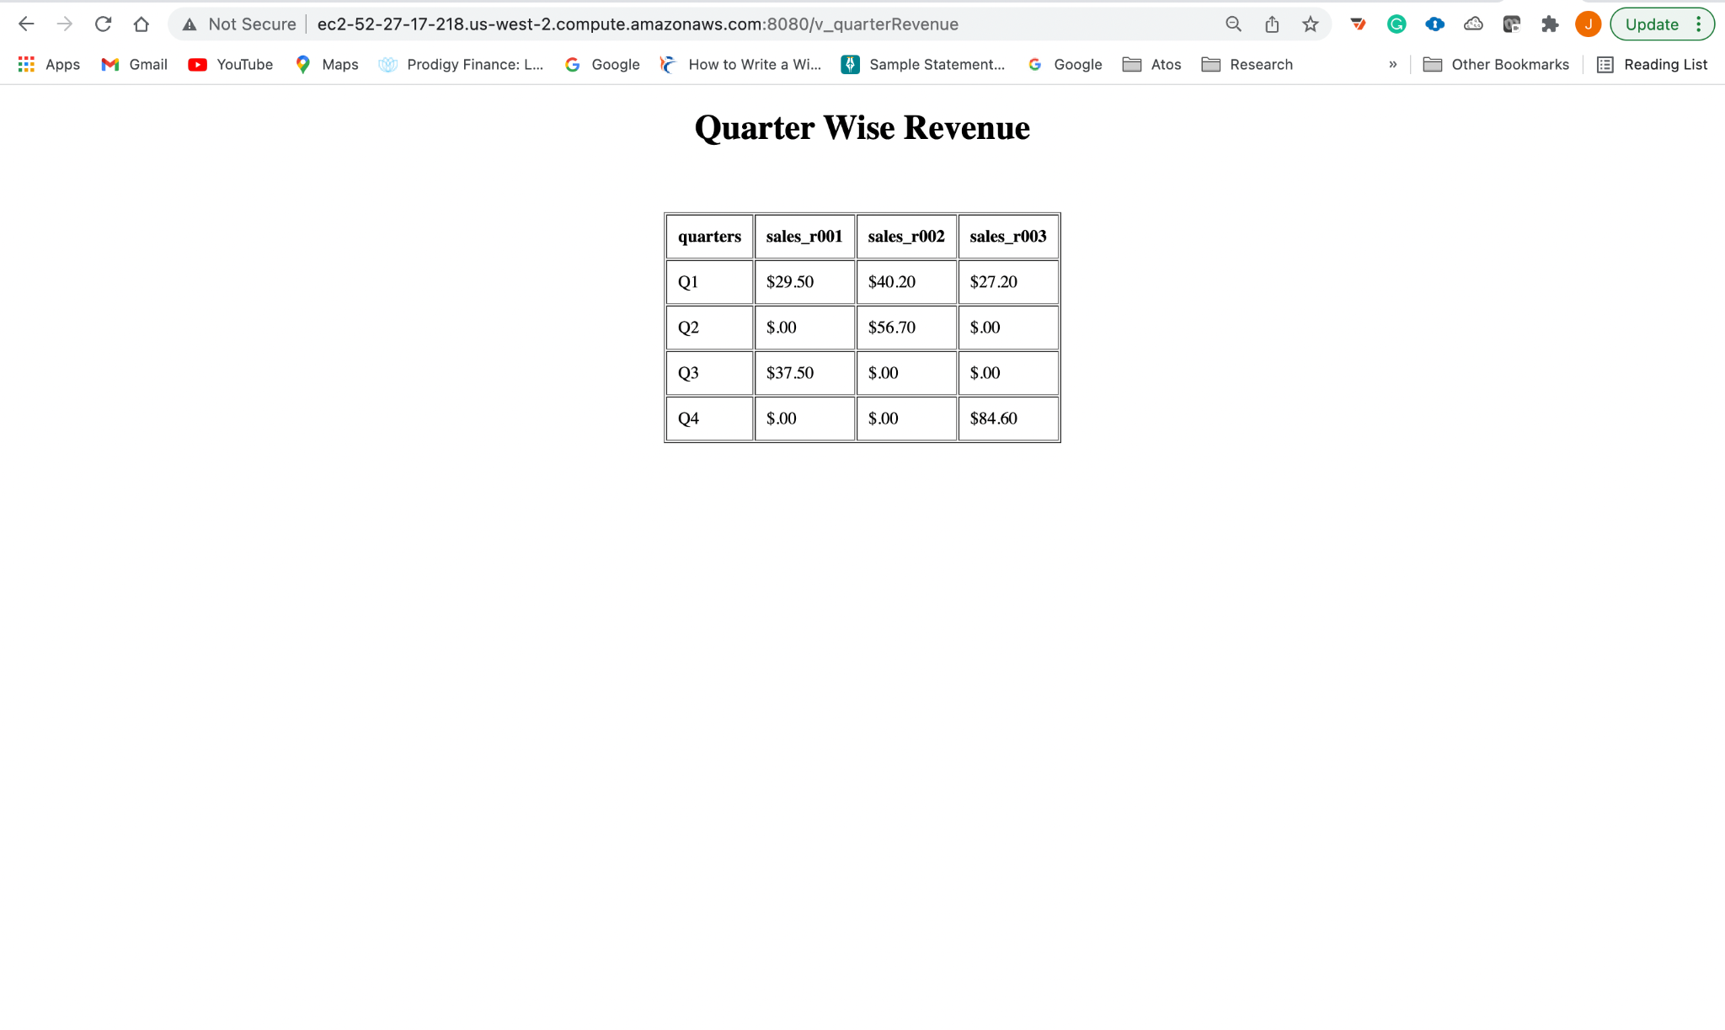

#### Department Statistics

This page displays the average salary of the department and also the highest and lowest salary that the department has.

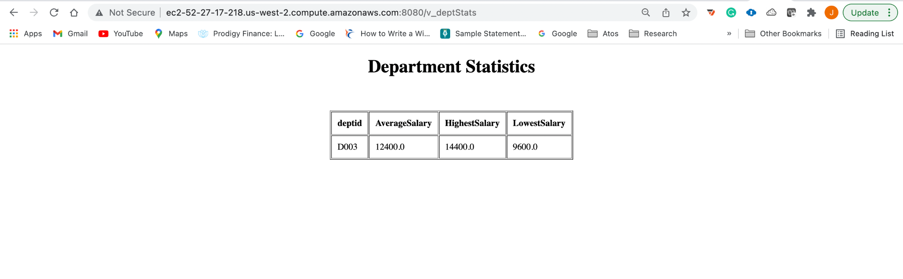

## Implementation Plan

Assumption: Report and design is available

Since, we have worked on the website creation and have the knowledge about the whole end to end functionality. This helped us in giving the estimate for the total cost from making to deploying the website. Below is the breakdown for the same :

Resource Cost = $1,248,000

Break down of resource cost. Assuming we outsource our work to Indian MNCs with an average pay of $30 per hour for 20 resources over a span of 1 year. The plan is to build iterative models of the ER, focusing on one part and then moving on to the next. So within 1 year, we would be ready with 1 portion of our ER.

Assuming we build the entire application over the span of 4 years. The resource cost would come out to be $4,992,000. Let's just round it off to $5M.

Hosting on an EC2 instance on Windows 32 GB Memory 8 Core processor 640 GB SSD disk 7 TB would cost approximately $240 per month. The actual cost depends on the amount of traffic it gets. Anything between 50$ to $100 can be needed to run an e-Commerce with decent traffic. And with the amount of traffic that we are expecting, we are assuming that deploying the website on EC2 server will cost around $1000 per month. That would bring our annual cost to $12,000.

Right now we have displayed and taken into account the restaurant and the items the restaurant offers, also registering the customer and storing their data. The future scope is to implement an order placing feature wherein the customer can place an order and get it delivered to his/her address. This needs an end to end functionality. Also, there needs to be check contraints and validation of data to secure our customer data. This should be a high priority task because we are storing the financial data for the customer which is highly sensitive.

## Appendix

### Lessons Learned

The whole project presented us with multiple challenges which enhanced our learning experience. Parts of projects such as building up a website from ground up, to establishing a database connection helped us expand our knowledge horizon. With our entry level experience in web development we are already coming up with numerous ideas which we could’ve implemented if time was not a constraint (no pun intended). This project has definitely helped us implement our understanding of the concepts studied in the classroom. From creating our own Entity Relationship Diagram, to translating it into relational format, normalizing it, using DDL commands to build the entire backend structure.

Looking at our fellow classmates’ presentations, we got a lot of insights into different alternative technologies that could be used to build the website. Ranging from php to java to .net, these different languages presented everyone with different challenges, for which we were happy to see unique solutions which our classmates presented.

### Chapter 3 SQL Table Creation Script

CREATE TABLE registration (

username VARCHAR(20)

CONSTRAINT reg_pk PRIMARY KEY,

password VARCHAR(20)

CONSTRAINT reg_pswd UNIQUE,

securityquestion VARCHAR(30)

CONSTRAINT reg_sqcq NOT NULL,

securityanswer VARCHAR(40)

CONSTRAINT reg_seca NOT NULL

);

CREATE TABLE cust_zip (

zip NUMBER(6)

CONSTRAINT custzip_zip_pk PRIMARY KEY,

city VARCHAR(20)

CONSTRAINT custzip_city NOT NULL,

state VARCHAR(20)

CONSTRAINT custzip_state NOT NULL

);

CREATE TABLE customers (

customerid VARCHAR(10)

CONSTRAINT cus_pk PRIMARY KEY,

fname VARCHAR(20)

CONSTRAINT cus_fname NOT NULL,

lname VARCHAR(20)

CONSTRAINT cus_lname NOT NULL,

email VARCHAR(50)

CONSTRAINT cus_email UNIQUE,

mobile NUMBER(10),

street VARCHAR(30),

zip NUMBER(5)

CONSTRAINT cus_zip REFERENCES cust_zip ( zip ),

refercode VARCHAR(4),

username VARCHAR(20)

CONSTRAINT cus_username REFERENCES registration

);

CREATE TABLE referrals (

referralid VARCHAR(10)

CONSTRAINT ref_refid PRIMARY KEY,

referaldate DATE,

referaldiscount NUMBER(3),

customerid VARCHAR(10)

CONSTRAINT ref_cusid REFERENCES customers

);

CREATE TABLE feedbacks (

feedbackid VARCHAR(4)

CONSTRAINT fbk_fbid PRIMARY KEY,

feedbacktime NUMBER(4,0),

feedbackdate DATE,

rating NUMBER(2, 1),

customerid VARCHAR(10)

CONSTRAINT fbk_cid REFERENCES customers

);

CREATE TABLE restaurant (

restaurantid VARCHAR(4)

CONSTRAINT rid_pk PRIMARY KEY,

restaurantname VARCHAR(20) NOT NULL,

restaurantaddress VARCHAR(50) NOT NULL,

opentime NUMBER(4,0) NOT NULL,

closingtime NUMBER(4,0) NOT NULL,

partnersince DATE NOT NULL,

ownername VARCHAR(20) NOT NULL,

ownerphonenumber NUMBER(10) NOT NULL

);

CREATE TABLE menu_items (

itemid VARCHAR(4)

CONSTRAINT mi_id PRIMARY KEY,

itemname VARCHAR(20),

itemprice NUMBER(4),

itemdescription VARCHAR(20),

restaurantid VARCHAR(4)

CONSTRAINT mi_rid

REFERENCES restaurant

);

CREATE TABLE restaurant_poc (

contactid VARCHAR(4),

restaurantid VARCHAR(4),

firstname VARCHAR(20) NOT NULL,

lastname VARCHAR(20) NOT NULL,

designationatrestaurant VARCHAR(20) NOT NULL,

pocsince DATE NOT NULL,

email VARCHAR(30) NOT NULL,

phonenumber NUMBER(10) NOT NULL,

CONSTRAINT poc_pk PRIMARY KEY ( contactid,

restaurantid ),

CONSTRAINT rid_fk FOREIGN KEY ( restaurantid )

REFERENCES restaurant ( restaurantid )

);

CREATE TABLE cards (

cardnumber NUMBER(16)

CONSTRAINT card_no PRIMARY KEY,

cardtype VARCHAR(10),

expirydate DATE,

cvv NUMBER(3),

nameoncard VARCHAR(20),

custommerid VARCHAR(10)

CONSTRAINT card_cid REFERENCES customers

);

--Create orders table

CREATE TABLE orders (

orderid VARCHAR(10)

CONSTRAINT ord_pk PRIMARY KEY,

customerid VARCHAR(10)

CONSTRAINT cus_id NOT NULL

REFERENCES customers,

deliveryaddress VARCHAR(100),

orderdate DATE,

ordertime NUMBER(4,0)

);

--Create order details table

CREATE TABLE order_details (

orderid VARCHAR(10)

REFERENCES orders,

itemid VARCHAR(10)

REFERENCES menu_items,

quantity NUMBER(4),

totalprice NUMBER(7),

PRIMARY KEY ( orderid,

itemid )

);

CREATE TABLE payment_methods (

paymentid VARCHAR(4)

CONSTRAINT pm_pid PRIMARY KEY,

paymentconfirmation VARCHAR(1),

finalamount NUMBER(6, 2),

totalprice NUMBER(6, 2),

discount NUMBER(2, 2),

deliveryfee NUMBER(2),

orderid VARCHAR(4)

CONSTRAINT pm_oid

REFERENCES orders

);

CREATE TABLE transaction_details (

transactionno NUMBER(10),

cardnumber NUMBER(16),

paymentid VARCHAR(4),

CONSTRAINT tran_pk PRIMARY KEY ( transactionno,

cardnumber,

paymentid ),

CONSTRAINT cno_fk FOREIGN KEY ( cardnumber )

REFERENCES cards ( cardnumber ),

CONSTRAINT pid_fk FOREIGN KEY ( paymentid )

REFERENCES payment_methods ( paymentid )

);

CREATE TABLE offers (

offerid VARCHAR(10)

CONSTRAINT oid_pk PRIMARY KEY,

offername VARCHAR(20) NOT NULL,

offercode VARCHAR(10) NOT NULL,

offercondition VARCHAR(20) NOT NULL,

offerstartdate DATE NOT NULL,

offerenddate DATE NOT NULL,

paymentid VARCHAR(4) NOT NULL,

CONSTRAINT pmt_fk FOREIGN KEY ( paymentid )

REFERENCES payment_methods ( paymentid )

);

CREATE TABLE departments (

deptid VARCHAR(4)

CONSTRAINT dep_pk PRIMARY KEY,

costcentre VARCHAR(4) NOT NULL,

deptname VARCHAR(20) NOT NULL

);

CREATE TABLE employees (

employeeid VARCHAR(4)

CONSTRAINT eid_pk PRIMARY KEY,

hiredate DATE,

ssn NUMBER(9)

CONSTRAINT emp_ssn_unq UNIQUE,

bloodgroup VARCHAR(4),

deptid VARCHAR(4),

CONSTRAINT did_fk FOREIGN KEY ( deptid )

REFERENCES departments ( deptid )

);

CREATE TABLE emp_ssn (

ssn NUMBER(9)

CONSTRAINT ssn_pk PRIMARY KEY,

fname VARCHAR(20) NOT NULL,

mname VARCHAR(20) NOT NULL,

lname VARCHAR(20) NOT NULL,

CONSTRAINT ssn_fk FOREIGN KEY ( ssn )

REFERENCES employees ( ssn )

);

CREATE TABLE employees_manager (

managerid VARCHAR(4)

CONSTRAINT mid_pk PRIMARY KEY,

yearofexperience NUMBER(3, 1) NOT NULL,

employeesunderhim NUMBER(2),

practice VARCHAR(20) NOT NULL,

CONSTRAINT mid_fk FOREIGN KEY ( managerid )

REFERENCES employees ( employeeid )

);

CREATE TABLE employees_support_agent (

supportagentid VARCHAR(4)

CONSTRAINT said_pk PRIMARY KEY,

querystatus VARCHAR(1) NOT NULL,

detailsofquery VARCHAR(100) NOT NULL,

querytype VARCHAR(10) NOT NULL,

CONSTRAINT said_fk FOREIGN KEY ( supportagentid )

REFERENCES employees ( employeeid )

);

CREATE TABLE employees_delivery_agent (

deliveryagentid VARCHAR(4)

CONSTRAINT daid_pk PRIMARY KEY,

numberoftrips NUMBER(5) NOT NULL,

currentlocation VARCHAR(20) NOT NULL,

rating NUMBER(2, 1),

activestatus VARCHAR(1),

CONSTRAINT daid_fk FOREIGN KEY ( deliveryagentid )

REFERENCES employees ( employeeid )

);

CREATE TABLE technical_vendors (

vendorid VARCHAR(4)

CONSTRAINT vid_pk PRIMARY KEY,

vendorname VARCHAR(20) NOT NULL,

contractstartdate DATE NOT NULL,

contractenddate DATE NOT NULL,

contractamount NUMBER(10, 2) NOT NULL,

technologyused VARCHAR(20),

managerid VARCHAR(4) NOT NULL,

CONSTRAINT tvmid_fk FOREIGN KEY ( managerid )

REFERENCES employees_manager ( managerid )

);

CREATE TABLE payroll (

payrollid VARCHAR(4)

CONSTRAINT prl_pk PRIMARY KEY,

paymentstartdate DATE NOT NULL,

paymentenddate DATE NOT NULL,

payrate NUMBER(5) NOT NULL,

taxes NUMBER(5) NOT NULL,

employeeid VARCHAR(4) NOT NULL,

CONSTRAINT payeid_fk FOREIGN KEY ( employeeid )

REFERENCES employees ( employeeid )

);

CREATE TABLE deliveryservices (

deliveryid VARCHAR(4)

CONSTRAINT dvid_pk PRIMARY KEY,

deliveryaddress VARCHAR(40) NOT NULL,

pickuplocation VARCHAR(40) NOT NULL,

timetodelivery NUMBER(2) NOT NULL,

deliveryagentid VARCHAR(4) NOT NULL,

paymentid VARCHAR(4) NOT NULL,

CONSTRAINT dvid_fk FOREIGN KEY ( deliveryagentid )

REFERENCES employees_delivery_agent ( deliveryagentid ),

CONSTRAINT dvpmtid_fk FOREIGN KEY ( paymentid )

REFERENCES payment_methods ( paymentid )

);

CREATE TABLE contractors (

contractorid VARCHAR(4)

CONSTRAINT ct_pk PRIMARY KEY,

contractorcompany VARCHAR(20) NOT NULL,

billingperhour NUMBER(6, 2) NOT NULL,

contractorsupervisorname VARCHAR(20) NOT NULL,

fname VARCHAR(20) NOT NULL,

lname VARCHAR(20) NOT NULL,

specialskills VARCHAR(20) NOT NULL,

startdate DATE NOT NULL,

enddate DATE NOT NULL,

managerid VARCHAR(4) NOT NULL,

CONSTRAINT ctmid_fk FOREIGN KEY ( managerid )

REFERENCES employees_manager ( managerid )

);

CREATE TABLE VEHICLE(

VIN VARCHAR(17) CONSTRAINT VIN_PK PRIMARY KEY,

DELIVERYAGENTID VARCHAR(10) CONSTRAINT DLV_FK REFERENCES EMPLOYEES_DELIVERY_AGENT,

VEHICLECOLOR VARCHAR(20),

VEHICLETYPE VARCHAR (10),

YEAROFMANUFACTURE NUMBER(4),

VEHICLENUMBER VARCHAR(10) UNIQUE NOT NULL,

INSURANCENUMBER NUMBER(10) UNIQUE NOT NULL

);

CREATE TABLE ARCHIVE_ORDERS

(

orderID varchar(10) constraint arch_ord_pk PRIMARY KEY,

customerID varchar(10) constraint arch_cus_Id NOT NULL references Customers,

deliveryAddress varchar(100),

orderDate date,

orderTime NUMBER(4,0)

);

CREATE TABLE ARCHIVE_ORDER_DETAILS

(

orderID VARCHAR(10) references ORDERS,

itemID VARCHAR(10) references MENU_ITEMS,

quantity NUMBER(4),

totalPrice NUMBER(7),

primary key(orderID, itemID)